名称：电木吸嘴

材质：胶木、电木（棕色、黄色）

产品概述：

电木吸嘴又名胶木吸嘴，机械加工强度高、尺寸稳定、耐油、耐腐蚀、坚韧耐磨、防静电、绝缘、耐高温（棕色瞬间耐高温480°-520°，黄色瞬间耐高温200°-250°）。

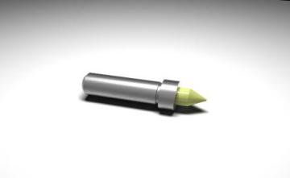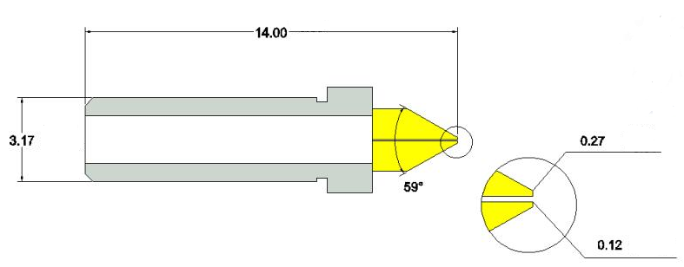

**技术参数**

|  |  |  |  |  |  |  |  |
| --- | --- | --- | --- | --- | --- | --- | --- |
| NO | 编号 | Part NO | OD | | ID | | 芯片范围 |
| inch | mm±0.005 | inch | mm±0.005 | inch |
| 1 | FY006514BY | FY-025068-14B-Y-60 | 025 | 0.065 | 0.68 | 0.17 | 4.5～5.5 |
| 2 | FY006514BC | FY-025068-14B-C-60 | 025 | 0.065 | 0.68 | 0.17 | 4.5～5.5 |
| 3 | FY007514BY | FY-030072-14B-Y-60 | 030 | 0.075 | 0.72 | 0.18 | 5.5～6.5 |
| 4 | FY007514BC | FY-030072-14B-C-60 | 030 | 0.075 | 0.72 | 0.18 | 5.5～6.5 |
| 5 | FY008514BY | FY-035084-14B-Y-60 | 035 | 0.085 | 0.84 | 0.21 | 7～8 |
| 6 | FY008514BC | FY-035084-14B-C-60 | 035 | 0.085 | 0.84 | 0.21 | 7～8 |
| 7 | FY010014BY | FY-040092-14B-Y-60 | 040 | 0.1 | 0.92 | 0.23 | 8～9 |
| 8 | FY010014BC | FY-040092-14B-C-60 | 040 | 0.1 | 0.92 | 0.23 | 8～9 |
| 9 | FY012014BY | FY-050108-14B-Y-60 | 050 | 0.12 | 1.08 | 0.27 | 9～12 |
| 10 | FY012014BC | FY-050108-14B-C-60 | 050 | 0.12 | 1.08 | 0.27 | 9～12 |
| 11 | FY015014BY | FY-060120-14B-Y-60 | 060 | 0.15 | 1.2 | 0.3 | 12～14 |
| 12 | FY015014BC | FY-060120-14B-C-60 | 060 | 0.15 | 1.2 | 0.3 | 12～14 |
| 13 | FY020014BY | FY-080156-14B-Y-60 | 080 | 0.2 | 1.56 | 0.39 | 14～16 |
| 14 | FY020014BC | FY-080156-14B-C-60 | 080 | 0.2 | 1.56 | 0.39 | 14～16 |
| 15 | FYXXXX14BY | FY-XXXXXX-14B-Y-60 | XXX | X.XX | X.XX | X.XX | XX～XX |
| 16 | FYXXXX14BC | FY-XXXXXX-14B-C-60 | XXX | X.XX | X.XX | X.XX | XX～XX |

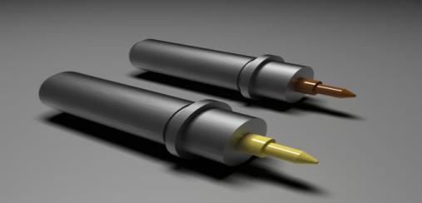

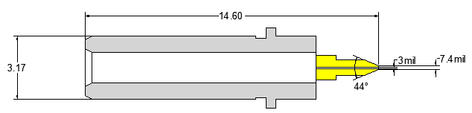

**技术参数**

|  |  |  |  |  |  |  |
| --- | --- | --- | --- | --- | --- | --- |
| NO | Part NO | OD | | ID | | 芯片范围 |
| inch | mm±0.005 | inch | mm±0.005 | inch |
| 1 | FY-025068-14.6B-Y-45 | 025 | 0.065 | 0.68 | 0.17 | 4.5～5.5 |
| 2 | FY-025068-14.6B-C-45 | 025 | 0.065 | 0.68 | 0.17 | 4.5～5.5 |
| 3 | FY-030072-14.6B-Y-45 | 030 | 0.075 | 0.72 | 0.18 | 5.5～6.5 |
| 4 | FY-030072-14.6B-C-45 | 030 | 0.075 | 0.72 | 0.18 | 5.5～6.5 |
| 5 | FY-035084-14.6B-Y-45 | 035 | 0.085 | 0.84 | 0.21 | 7～8 |
| 6 | FY-035084-14.6B-C-45 | 035 | 0.085 | 0.84 | 0.21 | 7～8 |
| 7 | FY-040092-14.6B-Y-45 | 040 | 0.1 | 0.92 | 0.23 | 8～9 |
| 8 | FY-040092-14.6B-C-45 | 040 | 0.1 | 0.92 | 0.23 | 8～9 |
| 9 | FY-050108-14.6B-Y-45 | 050 | 0.12 | 1.08 | 0.27 | 9～12 |
| 10 | FY-050108-14.6B-C-45 | 050 | 0.12 | 1.08 | 0.27 | 9～12 |
| 11 | FY-060120-14.6B-Y-45 | 060 | 0.15 | 1.2 | 0.3 | 12～14 |
| 12 | FY-060120-14.6B-C-45 | 060 | 0.15 | 1.2 | 0.3 | 12～14 |
| 13 | FY-080156-14.6B-Y-45 | 080 | 0.2 | 1.56 | 0.39 | 14～16 |
| 14 | FY-080156-14.6B-C-45 | 080 | 0.2 | 1.56 | 0.39 | 14～16 |
| 15 | FY-XXXXXX-14.6B-Y-45 | XXX | X.XX | X.XX | X.XX | XX～XX |
| 16 | FY-XXXXXX-14.6B-C-45 | XXX | X.XX | X.XX | X.XX | XX～XX |

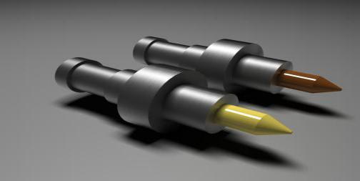

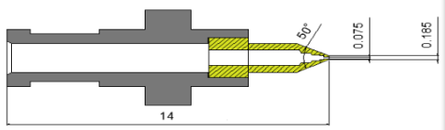

|  |  |  |  |  |  |  |
| --- | --- | --- | --- | --- | --- | --- |
| NO | Part NO | OD | | ID | | 芯片范围 |
| inch | mm±0.005 | inch | mm±0.005 | inch |
| 1 | FY-025068-14B-Y-5.0-50佳能 | 025 | 0.065 | 0.68 | 0.17 | 4.5～5.5 |
| 2 | FY-025068-14B-C-5.0-50佳能 | 025 | 0.065 | 0.68 | 0.17 | 4.5～5.5 |
| 3 | FY-030072-14B-Y-5.0-50佳能 | 030 | 0.075 | 0.72 | 0.18 | 5.5～6.5 |
| 4 | FY-030072-14B-C-5.0-50佳能 | 030 | 0.075 | 0.72 | 0.18 | 5.5～6.5 |
| 5 | FY-035084-14B-Y-5.0-50佳能 | 035 | 0.085 | 0.84 | 0.21 | 7～8 |
| 6 | FY-035084-14B-C-5.0-50佳能 | 035 | 0.085 | 0.84 | 0.21 | 7～8 |
| 7 | FY-040092-14B-Y-5.0-50佳能 | 040 | 0.1 | 0.92 | 0.23 | 8～9 |
| 8 | FY-040092-14B-C-5.0-50佳能 | 040 | 0.1 | 0.92 | 0.23 | 8～9 |
| 9 | FY-050108-14B-Y-5.0-50佳能 | 050 | 0.12 | 1.08 | 0.27 | 9～12 |
| 10 | FY-050108-14B-C-5.0-50佳能 | 050 | 0.12 | 1.08 | 0.27 | 9～12 |
| 11 | FY-060120-14B-Y-5.0-50佳能 | 060 | 0.15 | 1.2 | 0.3 | 12～14 |
| 12 | FY-060120-14B-C-5.0-50佳能 | 060 | 0.15 | 1.2 | 0.3 | 12～14 |
| 13 | FY-080156-14B-Y-5.0-50佳能 | 080 | 0.2 | 1.56 | 0.39 | 14～16 |
| 14 | FY-080156-14B-C-5.0-50佳能 | 080 | 0.2 | 1.56 | 0.39 | 14～16 |
| 15 | FY-XXXXXX-14B-Y-5.0-50佳能 | XXX | X.XX | X.XX | X.XX | XX～XX |
| 16 | FY-XXXXXX-14B-C-5.0-50佳能 | XXX | X.XX | X.XX | X.XX | XX～XX |

**技术参数**

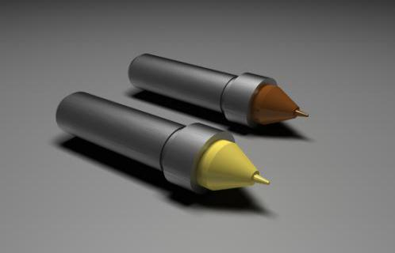 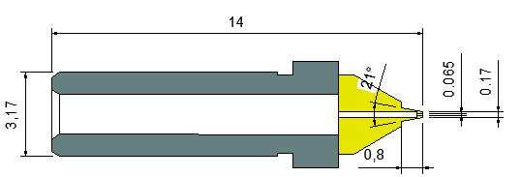

**技术参数**

|  |  |  |  |  |  |  |
| --- | --- | --- | --- | --- | --- | --- |
| NO | Part NO | OD | | ID | | 芯片范围 |
| inch | mm±0.005 | inch | mm±0.005 | inch |
| 1 | FY-025068-14B-Y-21-￠0.8 | 025 | 0.065 | 0.68 | 0.17 | 4.5～5.5 |
| 2 | FY-025068-14B-C-21-￠0.8 | 025 | 0.065 | 0.68 | 0.17 | 4.5～5.5 |
| 3 | FY-030072-14B-Y-21-￠0.8 | 030 | 0.075 | 0.72 | 0.18 | 5.5～6.5 |
| 4 | FY-030072-14B-C-21-￠0.8 | 030 | 0.075 | 0.72 | 0.18 | 5.5～6.5 |
| 5 | FY-035084-14B-Y-21-￠0.8 | 035 | 0.085 | 0.84 | 0.21 | 7～8 |
| 6 | FY-035084-14B-C-21-￠0.8 | 035 | 0.085 | 0.84 | 0.21 | 7～8 |
| 7 | FY-040092-14B-Y-21-￠0.8 | 040 | 0.1 | 0.92 | 0.23 | 8～9 |
| 8 | FY-040092-14B-C-21-￠0.8 | 040 | 0.1 | 0.92 | 0.23 | 8～9 |
| 9 | FY-050108-14B-Y-21-￠0.8 | 050 | 0.12 | 1.08 | 0.27 | 9～12 |
| 10 | FY-050108-14B-C-21-￠0.8 | 050 | 0.12 | 1.08 | 0.27 | 9～12 |
| 11 | FY-060120-14B-Y-21-￠0.8 | 060 | 0.15 | 1.2 | 0.3 | 12～14 |
| 12 | FY-060120-14B-C-21-￠0.8 | 060 | 0.15 | 1.2 | 0.3 | 12～14 |
| 13 | FY-080156-14B-Y-21-￠0.8 | 080 | 0.2 | 1.56 | 0.39 | 14～16 |
| 14 | FY-080156-14B-C-21-￠0.8 | 080 | 0.2 | 1.56 | 0.39 | 14～16 |
| 15 | FY-XXXXXX-14B-Y-21-￠0.8 | XXX | X.XX | X.XX | X.XX | XX～XX |
| 16 | FY-XXXXXX-14B-C-21-￠0.8 | XXX | X.XX | X.XX | X.XX | XX～XX |

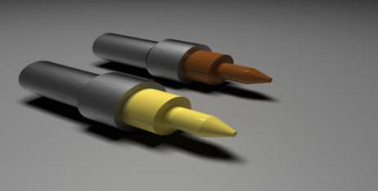

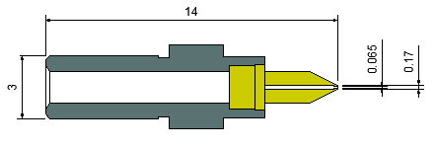

**技术参数**

|  |  |  |  |  |  |  |
| --- | --- | --- | --- | --- | --- | --- |
| NO | Part NO | OD | | ID | | 芯片范围 |
| inch | mm±0.005 | inch | mm±0.005 | inch |
| 1 | FY-025068-14B-Y-3.0-50-￠1.5 | 025 | 0.065 | 0.68 | 0.17 | 4.5～5.5 |
| 2 | FY-025068-14B-C-3.0-50-￠1.5 | 025 | 0.065 | 0.68 | 0.17 | 4.5～5.5 |
| 3 | FY-030072-14B-Y-3.0-50-￠1.5 | 030 | 0.075 | 0.72 | 0.18 | 5.5～6.5 |
| 4 | FY-030072-14B-C-3.0-50-￠1.5 | 030 | 0.075 | 0.72 | 0.18 | 5.5～6.5 |
| 5 | FY-035084-14B-Y-3.0-50-￠1.5 | 035 | 0.085 | 0.84 | 0.21 | 7～8 |
| 6 | FY-035084-14B-C-3.0-50-￠1.5 | 035 | 0.085 | 0.84 | 0.21 | 7～8 |
| 7 | FY-040092-14B-Y-3.0-50-￠1.5 | 040 | 0.1 | 0.92 | 0.23 | 8～9 |
| 8 | FY-040092-14B-C-3.0-50-￠1.5 | 040 | 0.1 | 0.92 | 0.23 | 8～9 |
| 9 | FY-050108-14B-Y-3.0-50-￠1.5 | 050 | 0.12 | 1.08 | 0.27 | 9～12 |
| 10 | FY-050108-14B-C-3.0-50-￠1.5 | 050 | 0.12 | 1.08 | 0.27 | 9～12 |
| 11 | FY-060120-14B-Y-3.0-50-￠1.5 | 060 | 0.15 | 1.2 | 0.3 | 12～14 |
| 12 | FY-060120-14B-C-3.0-50-￠1.5 | 060 | 0.15 | 1.2 | 0.3 | 12～14 |
| 13 | FY-080156-14B-Y-3.0-50-￠1.5 | 080 | 0.2 | 1.56 | 0.39 | 14～16 |
| 14 | FY-080156-14B-C-3.0-50-￠1.5 | 080 | 0.2 | 1.56 | 0.39 | 14～16 |
| 15 | FY-XXXXXX-14B-Y-3.0-50-￠1.5 | XXX | X.XX | X.XX | X.XX | XX～XX |
| 16 | FY-XXXXXX-14B-C-3.0-50-￠1.5 | XXX | X.XX | X.XX | X.XX | XX～XX |

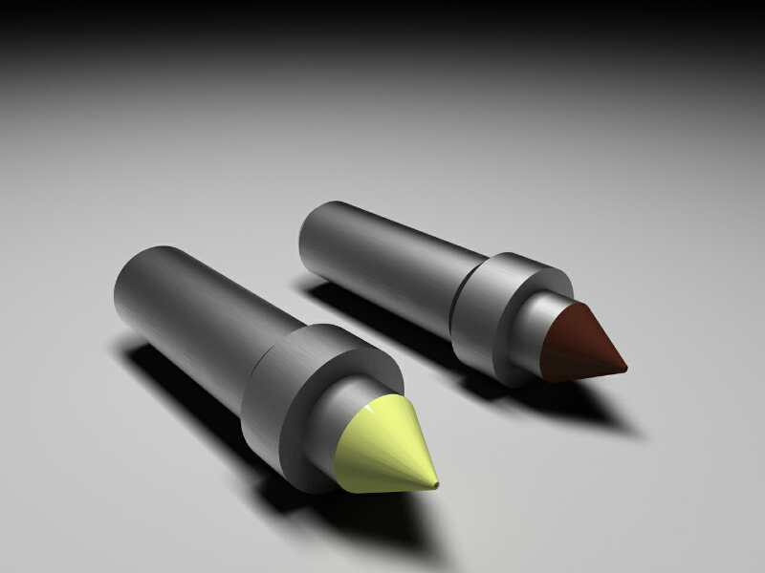

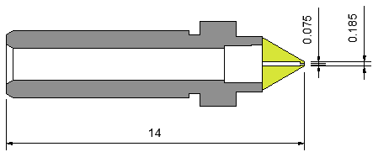

**技术参数**

|  |  |  |  |  |  |  |
| --- | --- | --- | --- | --- | --- | --- |
| NO | Part NO | OD | | ID | | 芯片范围 |
| inch | mm±0.005 | inch | mm±0.005 | inch |
| 1 | FY-025068-14B-Y-60 | 025 | 0.065 | 0.68 | 0.17 | 4.5～5.5 |
| 2 | FY-025068-14B-C-60 | 025 | 0.065 | 0.68 | 0.17 | 4.5～5.5 |
| 3 | FY-030072-14B-Y-60 | 030 | 0.075 | 0.72 | 0.18 | 5.5～6.5 |
| 4 | FY-030072-14B-C-60 | 030 | 0.075 | 0.72 | 0.18 | 5.5～6.5 |
| 5 | FY-035084-14B-Y-60 | 035 | 0.085 | 0.84 | 0.21 | 7～8 |
| 6 | FY-035084-14B-C-60 | 035 | 0.085 | 0.84 | 0.21 | 7～8 |
| 7 | FY-040092-14B-Y-60 | 040 | 0.1 | 0.92 | 0.23 | 8～9 |
| 8 | FY-040092-14B-C-60 | 040 | 0.1 | 0.92 | 0.23 | 8～9 |
| 9 | FY-050108-14B-Y-60 | 050 | 0.12 | 1.08 | 0.27 | 9～12 |
| 10 | FY-050108-14B-C-60 | 050 | 0.12 | 1.08 | 0.27 | 9～12 |
| 11 | FY-060120-14B-Y-60 | 060 | 0.15 | 1.2 | 0.3 | 12～14 |
| 12 | FY-060120-14B-C-60 | 060 | 0.15 | 1.2 | 0.3 | 12～14 |
| 13 | FY-080156-14B-Y-60 | 080 | 0.2 | 1.56 | 0.39 | 14～16 |
| 14 | FY-080156-14B-C-60 | 080 | 0.2 | 1.56 | 0.39 | 14～16 |
| 15 | FY-XXXXXX-14B-Y-60 | XXX | X.XX | X.XX | X.XX | XX～XX |
| 16 | FY-XXXXXX-14B-C-60 | XXX | X.XX | X.XX | X.XX | XX～XX |

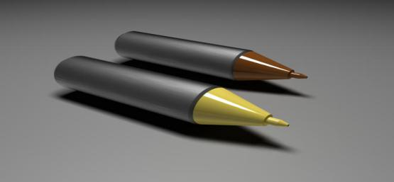 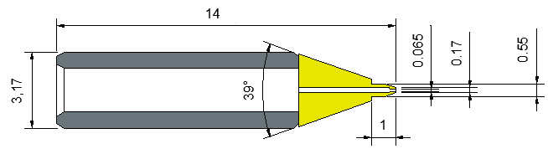

**技术参数**

|  |  |  |  |  |  |  |
| --- | --- | --- | --- | --- | --- | --- |
| NO | Part NO | OD | | ID | | 芯片范围 |
| inch | mm±0.005 | inch | mm±0.005 | inch |
| 1 | FY-025068-14A-Y-39-￠0.55 | 025 | 0.065 | 0.68 | 0.17 | 4.5～5.5 |
| 2 | FY-025068-14A-C-39-￠0.55 | 025 | 0.065 | 0.68 | 0.17 | 4.5～5.5 |
| 3 | FY-030072-14A-Y-39-￠0.55 | 030 | 0.075 | 0.72 | 0.18 | 5.5～6.5 |
| 4 | FY-030072-14A-C-39-￠0.55 | 030 | 0.075 | 0.72 | 0.18 | 5.5～6.5 |
| 5 | FY-035084-14A-Y-39-￠0.55 | 035 | 0.085 | 0.84 | 0.21 | 7～8 |
| 6 | FY-035084-14A-C-39-￠0.55 | 035 | 0.085 | 0.84 | 0.21 | 7～8 |
| 7 | FY-040092-14A-Y-39-￠0.55 | 040 | 0.1 | 0.92 | 0.23 | 8～9 |
| 8 | FY-040092-14A-C-39-￠0.55 | 040 | 0.1 | 0.92 | 0.23 | 8～9 |
| 9 | FY-050108-14A-Y-39-￠0.55 | 050 | 0.12 | 1.08 | 0.27 | 9～12 |
| 10 | FY-050108-14A-C-39-￠0.55 | 050 | 0.12 | 1.08 | 0.27 | 9～12 |
| 11 | FY-060120-14A-Y-39-￠0.55 | 060 | 0.15 | 1.2 | 0.3 | 12～14 |
| 12 | FY-060120-14A-C-39-￠0.55 | 060 | 0.15 | 1.2 | 0.3 | 12～14 |
| 13 | FY-080156-14A-Y-39-￠0.55 | 080 | 0.2 | 1.56 | 0.39 | 14～16 |
| 14 | FY-080156-14A-C-39-￠0.55 | 080 | 0.2 | 1.56 | 0.39 | 14～16 |
| 15 | FY-XXXXXX-14A-Y-39-￠0.55 | XXX | X.XX | X.XX | X.XX | XX～XX |
| 16 | FY-XXXXXX-14A-C-39-￠0.55 | XXX | X.XX | X.XX | X.XX | XX～XX |

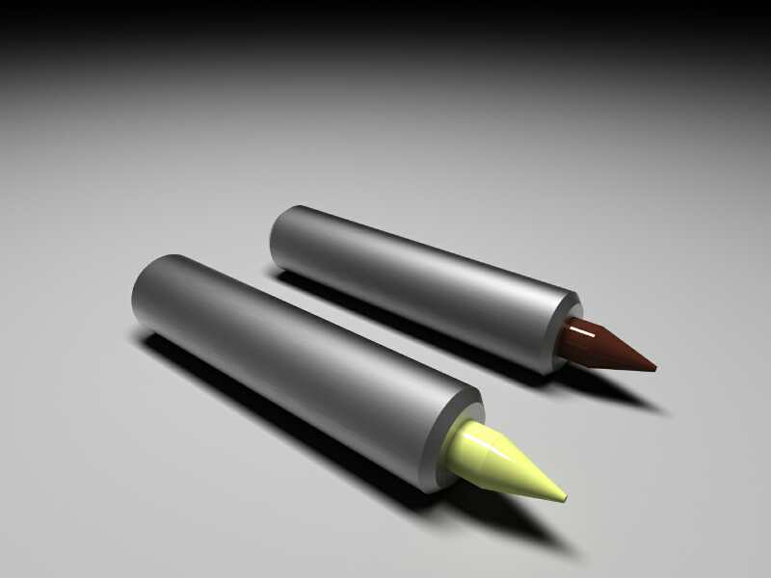

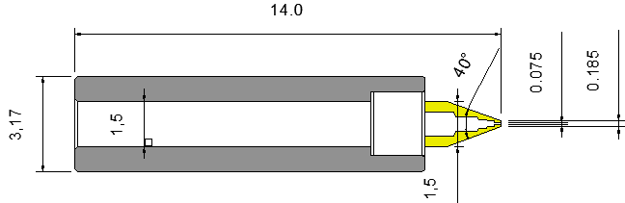

**技术参数**

|  |  |  |  |  |  |  |
| --- | --- | --- | --- | --- | --- | --- |
| NO | Part NO | OD | | ID | | 芯片范围 |
| inch | mm±0.005 | inch | mm±0.005 | inch |
| 1 | FY-025068-14A-Y-40-￠1.5 | 025 | 0.065 | 0.68 | 0.17 | 4.5～5.5 |
| 2 | FY-025068-14A-C-40-￠1.5 | 025 | 0.065 | 0.68 | 0.17 | 4.5～5.5 |
| 3 | FY-030072-14A-Y-40-￠1.5 | 030 | 0.075 | 0.72 | 0.18 | 5.5～6.5 |
| 4 | FY-030072-14A-C-40-￠1.5 | 030 | 0.075 | 0.72 | 0.18 | 5.5～6.5 |
| 5 | FY-035084-14A-Y-40-￠1.5 | 035 | 0.085 | 0.84 | 0.21 | 7～8 |
| 6 | FY-035084-14A-C-40-￠1.5 | 035 | 0.085 | 0.84 | 0.21 | 7～8 |
| 7 | FY-040092-14A-Y-40-￠1.5 | 040 | 0.1 | 0.92 | 0.23 | 8～9 |
| 8 | FY-040092-14A-C-40-￠1.5 | 040 | 0.1 | 0.92 | 0.23 | 8～9 |
| 9 | FY-050108-14A-Y-40-￠1.5 | 050 | 0.12 | 1.08 | 0.27 | 9～12 |
| 10 | FY-050108-14A-C-40-￠1.5 | 050 | 0.12 | 1.08 | 0.27 | 9～12 |
| 11 | FY-060120-14A-Y-40-￠1.5 | 060 | 0.15 | 1.2 | 0.3 | 12～14 |
| 12 | FY-060120-14A-C-40-￠1.5 | 060 | 0.15 | 1.2 | 0.3 | 12～14 |
| 13 | FY-080156-14A-Y-40-￠1.5 | 080 | 0.2 | 1.56 | 0.39 | 14～16 |
| 14 | FY-080156-14A-C-40-￠1.5 | 080 | 0.2 | 1.56 | 0.39 | 14～16 |
| 15 | FY-XXXXXX-14A-Y-40-￠1.5 | XXX | X.XX | X.XX | X.XX | XX～XX |
| 16 | FY-XXXXXX-14A-C-40-￠1.5 | XXX | X.XX | X.XX | X.XX | XX～XX |

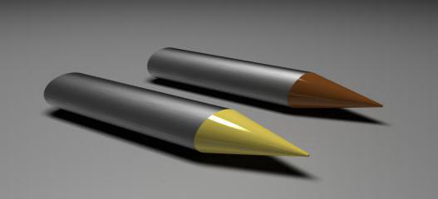

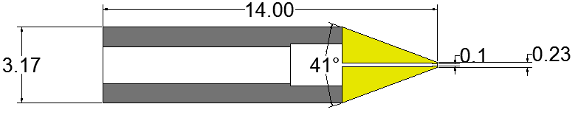 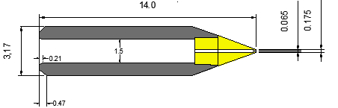

**技术参数**

|  |  |  |  |  |  |  |
| --- | --- | --- | --- | --- | --- | --- |
| NO | Part NO | OD | | ID | | 芯片范围 |
| inch | mm±0.005 | inch | mm±0.005 | inch |
| 1 | FY-025068-14A-Y-40 | 025 | 0.065 | 0.68 | 0.17 | 4.5～5.5 |
| 2 | FY-025068-14A-C-40 | 025 | 0.065 | 0.68 | 0.17 | 4.5～5.5 |
| 3 | FY-030072-14A-Y-40 | 030 | 0.075 | 0.72 | 0.18 | 5.5～6.5 |
| 4 | FY-030072-14A-C-40 | 030 | 0.075 | 0.72 | 0.18 | 5.5～6.5 |
| 5 | FY-035084-14A-Y-40 | 035 | 0.085 | 0.84 | 0.21 | 7～8 |
| 6 | FY-035084-14A-C-40 | 035 | 0.085 | 0.84 | 0.21 | 7～8 |
| 7 | FY-040092-14A-Y-40 | 040 | 0.1 | 0.92 | 0.23 | 8～9 |
| 8 | FY-040092-14A-C-40 | 040 | 0.1 | 0.92 | 0.23 | 8～9 |
| 9 | FY-050108-14A-Y-40 | 050 | 0.12 | 1.08 | 0.27 | 9～12 |
| 10 | FY-050108-14A-C-40 | 050 | 0.12 | 1.08 | 0.27 | 9～12 |
| 11 | FY-060120-14A-Y-40 | 060 | 0.15 | 1.2 | 0.3 | 12～14 |
| 12 | FY-060120-14A-C-40 | 060 | 0.15 | 1.2 | 0.3 | 12～14 |
| 13 | FY-080156-14A-Y-40 | 080 | 0.2 | 1.56 | 0.39 | 14～16 |
| 14 | FY-080156-14A-C-40 | 080 | 0.2 | 1.56 | 0.39 | 14～16 |
| 15 | FY-XXXXXX-14A-Y-40 | XXX | X.XX | X.XX | X.XX | XX～XX |
| 16 | FY-XXXXXX-14A-C-40 | XXX | X.XX | X.XX | X.XX | XX～XX |

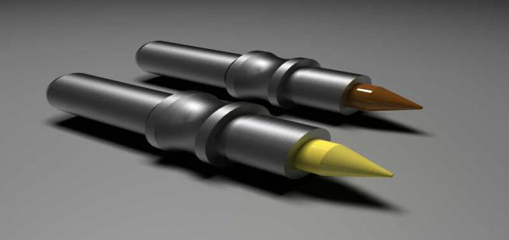

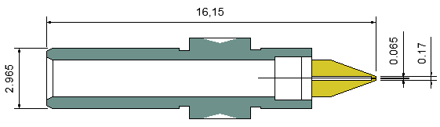

**技术参数**

|  |  |  |  |  |  |  |
| --- | --- | --- | --- | --- | --- | --- |
| NO | Part NO | OD | | ID | | 芯片范围 |
| inch | mm±0.005 | inch | mm±0.005 | inch |
| 1 | FY-025068-16B-Y-1.8-40 | 025 | 0.065 | 0.68 | 0.17 | 4.5～5.5 |
| 2 | FY-025068-16B-C-1.8-40 | 025 | 0.065 | 0.68 | 0.17 | 4.5～5.5 |
| 3 | FY-030072-16B-Y-1.8-40 | 030 | 0.075 | 0.72 | 0.18 | 5.5～6.5 |
| 4 | FY-030072-16B-C-1.8-40 | 030 | 0.075 | 0.72 | 0.18 | 5.5～6.5 |
| 5 | FY-035084-16B-Y-1.8-40 | 035 | 0.085 | 0.84 | 0.21 | 7～8 |
| 6 | FY-035084-16B-C-1.8-40 | 035 | 0.085 | 0.84 | 0.21 | 7～8 |
| 7 | FY-040092-16B-Y-1.8-40 | 040 | 0.1 | 0.92 | 0.23 | 8～9 |
| 8 | FY-040092-16B-C-1.8-40 | 040 | 0.1 | 0.92 | 0.23 | 8～9 |
| 9 | FY-050108-16B-Y-1.8-40 | 050 | 0.12 | 1.08 | 0.27 | 9～12 |
| 10 | FY-050108-16B-C-1.8-40 | 050 | 0.12 | 1.08 | 0.27 | 9～12 |
| 11 | FY-060120-16B-Y-1.8-40 | 060 | 0.15 | 1.2 | 0.3 | 12～14 |
| 12 | FY-060120-16B-C-1.8-40 | 060 | 0.15 | 1.2 | 0.3 | 12～14 |
| 13 | FY-080156-16B-Y-1.8-40 | 080 | 0.2 | 1.56 | 0.39 | 14～16 |
| 14 | FY-080156-16B-C-1.8-40 | 080 | 0.2 | 1.56 | 0.39 | 14～16 |
| 15 | FY-XXXXXX-16B-Y-1.8-40 | XXX | X.XX | X.XX | X.XX | XX～XX |
| 16 | FY-XXXXXX-16B-C-1.8-40 | XXX | X.XX | X.XX | X.XX | XX～XX |



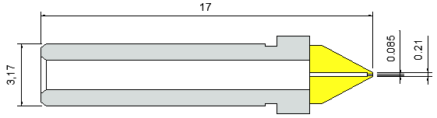

**技术参数**

|  |  |  |  |  |  |  |
| --- | --- | --- | --- | --- | --- | --- |
| NO | Part NO | OD | | ID | | 芯片范围 |
| inch | mm±0.005 | inch | mm±0.005 | inch |
| 1 | FY-025068-17B-Y--60 | 025 | 0.065 | 0.68 | 0.17 | 4.5～5.5 |
| 2* | FY-025068-17B-C--60 | 025 | 0.065 | 0.68 | 0.17 | 4.5～5.5 |
| 3 | FY-030072-17B-Y--60 | 030 | 0.075 | 0.72 | 0.18 | 5.5～6.5 |
| 4 | FY-030072-17B-C--60 | 030 | 0.075 | 0.72 | 0.18 | 5.5～6.5 |
| 5 | FY-035084-17B-Y--60 | 035 | 0.085 | 0.84 | 0.21 | 7～8 |
| 6 | FY-035084-17B-C--60 | 035 | 0.085 | 0.84 | 0.21 | 7～8 |
| 7 | FY-040092-17B-Y--60 | 040 | 0.1 | 0.92 | 0.23 | 8～9 |
| 8 | FY-040092-17B-C--60 | 040 | 0.1 | 0.92 | 0.23 | 8～9 |
| 9 | FY-050108-17B-Y--60 | 050 | 0.12 | 1.08 | 0.27 | 9～12 |
| 10 | FY-050108-17B-C--60 | 050 | 0.12 | 1.08 | 0.27 | 9～12 |
| 11 | FY-060120-17B-Y--60 | 060 | 0.15 | 1.2 | 0.3 | 12～14 |
| 12 | FY-060120-17B-C--60 | 060 | 0.15 | 1.2 | 0.3 | 12～14 |
| 13 | FY-080156-17B-Y--60 | 080 | 0.2 | 1.56 | 0.39 | 14～16 |
| 14 | FY-080156-17B-C--60 | 080 | 0.2 | 1.56 | 0.39 | 14～16 |
| 15 | FY-XXXXXX-17B-Y--60 | XXX | X.XX | X.XX | X.XX | XX～XX |
| 16 | FY-XXXXXX-17B-C--60 | XXX | X.XX | X.XX | X.XX | XX～XX |

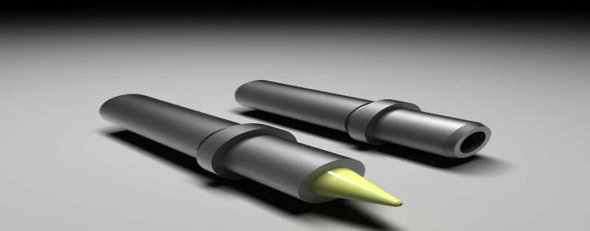

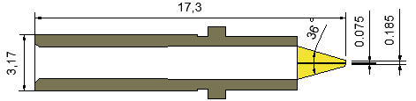

**技术参数**

|  |  |  |  |  |  |  |
| --- | --- | --- | --- | --- | --- | --- |
| NO | Part NO | OD | | ID | | 芯片范围 |
| inch | mm±0.005 | inch | mm±0.005 | inch |
| 1 | FY-025068-17.3B-Y-36 | 025 | 0.065 | 0.68 | 0.17 | 4.5～5.5 |
| 2 | FY-025068-17.3B-C-36 | 025 | 0.065 | 0.68 | 0.17 | 4.5～5.5 |
| 3 | FY-030072-17.3B-Y-36 | 030 | 0.075 | 0.72 | 0.18 | 5.5～6.5 |
| 4 | FY-030072-17.3B-C-36 | 030 | 0.075 | 0.72 | 0.18 | 5.5～6.5 |
| 5 | FY-035084-17.3B-Y-36 | 035 | 0.085 | 0.84 | 0.21 | 7～8 |
| 6 | FY-035084-17.3B-C-36 | 035 | 0.085 | 0.84 | 0.21 | 7～8 |
| 7 | FY-040092-17.3B-Y-36 | 040 | 0.1 | 0.92 | 0.23 | 8～9 |
| 8 | FY-040092-17.3B-C-36 | 040 | 0.1 | 0.92 | 0.23 | 8～9 |
| 9 | FY-050108-17.3B-Y-36 | 050 | 0.12 | 1.08 | 0.27 | 9～12 |
| 10 | FY-050108-17.3B-C-36 | 050 | 0.12 | 1.08 | 0.27 | 9～12 |
| 11 | FY-036120-17.3B-Y-36 | 060 | 0.15 | 1.2 | 0.3 | 12～14 |
| 12 | FY-036120-17.3B-C-36 | 060 | 0.15 | 1.2 | 0.3 | 12～14 |
| 13 | FY-080156-17.3B-Y-36 | 080 | 0.2 | 1.56 | 0.39 | 14～16 |
| 14 | FY-080156-17.3B-C-36 | 080 | 0.2 | 1.56 | 0.39 | 14～16 |
| 15 | FY-XXXXXX-17.3B-Y-36 | XXX | X.XX | X.XX | X.XX | XX～XX |
| 16 | FY-XXXXXX-17.3B-C-36 | XXX | X.XX | X.XX | X.XX | XX～XX |

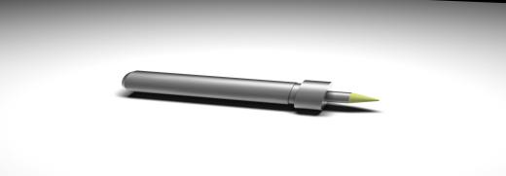

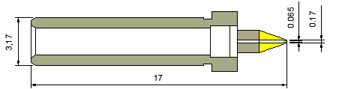

**技术参数**

|  |  |  |  |  |  |  |
| --- | --- | --- | --- | --- | --- | --- |
| NO | Part NO | OD | | ID | | 芯片范围 |
| inch | mm±0.005 | inch | mm±0.005 | inch |
| 1 | FY-025068-17B-Y-40-￠1.5 | 025 | 0.065 | 0.68 | 0.17 | 4.5～5.5 |
| 2 | FY-025068-17B-C-40-￠1.5 | 025 | 0.065 | 0.68 | 0.17 | 4.5～5.5 |
| 3 | FY-030072-17B-Y-40-￠1.5 | 030 | 0.075 | 0.72 | 0.18 | 5.5～6.5 |
| 4 | FY-030072-17B-C-40-￠1.5 | 030 | 0.075 | 0.72 | 0.18 | 5.5～6.5 |
| 5 | FY-035084-17B-Y-40-￠1.5 | 035 | 0.085 | 0.84 | 0.21 | 7～8 |
| 6 | FY-035084-17B-C-40-￠1.5 | 035 | 0.085 | 0.84 | 0.21 | 7～8 |
| 7 | FY-040092-17B-Y-40-￠1.5 | 040 | 0.1 | 0.92 | 0.23 | 8～9 |
| 8 | FY-040092-17B-C-40-￠1.5 | 040 | 0.1 | 0.92 | 0.23 | 8～9 |
| 9 | FY-050108-17B-Y-40-￠1.5 | 050 | 0.12 | 1.08 | 0.27 | 9～12 |
| 10 | FY-050108-17B-C-40-￠1.5 | 050 | 0.12 | 1.08 | 0.27 | 9～12 |
| 11 | FY-060120-17B-Y-40-￠1.5 | 060 | 0.15 | 1.2 | 0.3 | 12～14 |
| 12 | FY-060120-17B-C-40-￠1.5 | 060 | 0.15 | 1.2 | 0.3 | 12～14 |
| 13 | FY-080156-17B-Y-40-￠1.5 | 080 | 0.2 | 1.56 | 0.39 | 14～16 |
| 14 | FY-080156-17B-C-40-￠1.5 | 080 | 0.2 | 1.56 | 0.39 | 14～16 |
| 15 | FY-XXXXXX-17B-Y-40-￠1.5 | XXX | X.XX | X.XX | X.XX | XX～XX |
| 16 | FY-XXXXXX-17B-C-40-￠1.5 | XXX | X.XX | X.XX | X.XX | XX～XX |



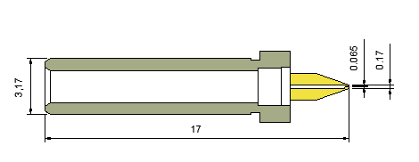

**技术参数**

|  |  |  |  |  |  |  |
| --- | --- | --- | --- | --- | --- | --- |
| NO | Part NO | OD | | ID | | 芯片范围 |
| inch | mm±0.005 | inch | mm±0.005 | inch |
| 1 | FY-025068-17B-Y-40-￠1.5 | 025 | 0.065 | 0.68 | 0.17 | 4.5～5.5 |
| 2 | FY-025068-17B-C-40-￠1.5 | 025 | 0.065 | 0.68 | 0.17 | 4.5～5.5 |
| 3 | FY-030072-17B-Y-40-￠1.5 | 030 | 0.075 | 0.72 | 0.18 | 5.5～6.5 |
| 4 | FY-030072-17B-C-40-￠1.5 | 030 | 0.075 | 0.72 | 0.18 | 5.5～6.5 |
| 5 | FY-035084-17B-Y-40-￠1.5 | 035 | 0.085 | 0.84 | 0.21 | 7～8 |
| 6 | FY-035084-17B-C-40-￠1.5 | 035 | 0.085 | 0.84 | 0.21 | 7～8 |
| 7 | FY-040092-17B-Y-40-￠1.5 | 040 | 0.1 | 0.92 | 0.23 | 8～9 |
| 8 | FY-040092-17B-C-40-￠1.5 | 040 | 0.1 | 0.92 | 0.23 | 8～9 |
| 9 | FY-050108-17B-Y-40-￠1.5 | 050 | 0.12 | 1.08 | 0.27 | 9～12 |
| 10 | FY-050108-17B-C-40-￠1.5 | 050 | 0.12 | 1.08 | 0.27 | 9～12 |
| 11 | FY-060120-17B-Y-40-￠1.5 | 060 | 0.15 | 1.2 | 0.3 | 12～14 |
| 12 | FY-060120-17B-C-40-￠1.5 | 060 | 0.15 | 1.2 | 0.3 | 12～14 |
| 13 | FY-080156-17B-Y-40-￠1.5 | 080 | 0.2 | 1.56 | 0.39 | 14～16 |
| 14 | FY-080156-17B-C-40-￠1.5 | 080 | 0.2 | 1.56 | 0.39 | 14～16 |
| 15 | FY-XXXXXX-17B-Y-40-￠1.5 | XXX | X.XX | X.XX | X.XX | XX～XX |
| 16 | FY-XXXXXX-17B-C-40-￠1.5 | XXX | X.XX | X.XX | X.XX | XX～XX |



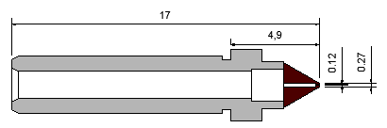

**技术参数**

|  |  |  |  |  |  |  |
| --- | --- | --- | --- | --- | --- | --- |
| NO | Part NO | OD | | ID | | 芯片范围 |
| inch | mm±0.005 | inch | mm±0.005 | inch |
| 1 | FY-025068-17B-Y-60 | 025 | 0.065 | 0.68 | 0.17 | 4.5～5.5 |
| 2 | FY-025068-17B-C-60 | 025 | 0.065 | 0.68 | 0.17 | 4.5～5.5 |
| 3 | FY-030072-17B-Y-60 | 030 | 0.075 | 0.72 | 0.18 | 5.5～6.5 |
| 4 | FY-030072-17B-C-60 | 030 | 0.075 | 0.72 | 0.18 | 5.5～6.5 |
| 5 | FY-035084-17B-Y-60 | 035 | 0.085 | 0.84 | 0.21 | 7～8 |
| 6 | FY-035084-17B-C-60 | 035 | 0.085 | 0.84 | 0.21 | 7～8 |
| 7 | FY-040092-17B-Y-60 | 040 | 0.1 | 0.92 | 0.23 | 8～9 |
| 8 | FY-040092-17B-C-60 | 040 | 0.1 | 0.92 | 0.23 | 8～9 |
| 9 | FY-050108-17B-Y-60 | 050 | 0.12 | 1.08 | 0.27 | 9～12 |
| 10 | FY-050108-17B-C-60 | 050 | 0.12 | 1.08 | 0.27 | 9～12 |
| 11 | FY-060120-17B-Y-60 | 060 | 0.15 | 1.2 | 0.3 | 12～14 |
| 12 | FY-060120-17B-C-60 | 060 | 0.15 | 1.2 | 0.3 | 12～14 |
| 13 | FY-080156-17B-Y-60 | 080 | 0.2 | 1.56 | 0.39 | 14～16 |
| 14 | FY-080156-17B-C-60 | 080 | 0.2 | 1.56 | 0.39 | 14～16 |
| 15 | FY-XXXXXX-17B-Y-60 | XXX | X.XX | X.XX | X.XX | XX～XX |
| 16 | FY-XXXXXX-17B-C-60 | XXX | X.XX | X.XX | X.XX | XX～XX |

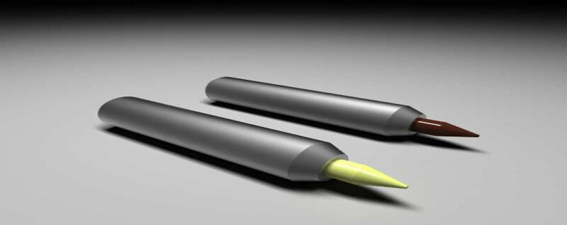

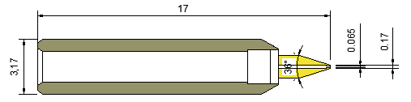

**技术参数**

|  |  |  |  |  |  |  |
| --- | --- | --- | --- | --- | --- | --- |
| NO | Part NO | OD | | ID | | 芯片范围 |
| inch | mm±0.005 | inch | mm±0.005 | inch |
| 1 | FY-025068-17A-Y-36-￠1.35 | 025 | 0.065 | 0.68 | 0.17 | 4.5～5.5 |
| 2 | FY-025068-17A-C-36-￠1.35 | 025 | 0.065 | 0.68 | 0.17 | 4.5～5.5 |
| 3 | FY-030072-17A-Y-36-￠1.35 | 030 | 0.075 | 0.72 | 0.18 | 5.5～6.5 |
| 4 | FY-030072-17A-C-36-￠1.35 | 030 | 0.075 | 0.72 | 0.18 | 5.5～6.5 |
| 5 | FY-036084-17A-Y-36-￠1.35 | 035 | 0.085 | 0.84 | 0.21 | 7～8 |
| 6 | FY-036084-17A-C-36-￠1.35 | 035 | 0.085 | 0.84 | 0.21 | 7～8 |
| 7 | FY-040092-17A-Y-36-￠1.35 | 040 | 0.1 | 0.92 | 0.23 | 8～9 |
| 8 | FY-040092-17A-C-36-￠1.35 | 040 | 0.1 | 0.92 | 0.23 | 8～9 |
| 9 | FY-050108-17A-Y-36-￠1.35 | 050 | 0.12 | 1.08 | 0.27 | 9～12 |
| 10 | FY-050108-17A-C-36-￠1.35 | 050 | 0.12 | 1.08 | 0.27 | 9～12 |
| 11 | FY-060120-17A-Y-36-￠1.35 | 060 | 0.15 | 1.2 | 0.3 | 12～14 |
| 12 | FY-060120-17A-C-36-￠1.35 | 060 | 0.15 | 1.2 | 0.3 | 12～14 |
| 13 | FY-080156-17A-Y-36-￠1.35 | 080 | 0.2 | 1.56 | 0.39 | 14～16 |
| 14 | FY-080156-17A-C-36-￠1.35 | 080 | 0.2 | 1.56 | 0.39 | 14～16 |
| 15 | FY-XXXXXX-17A-Y-36-￠1.35 | XXX | X.XX | X.XX | X.XX | XX～XX |
| 16 | FY-XXXXXX-17A-C-36-￠1.35 | XXX | X.XX | X.XX | X.XX | XX～XX |

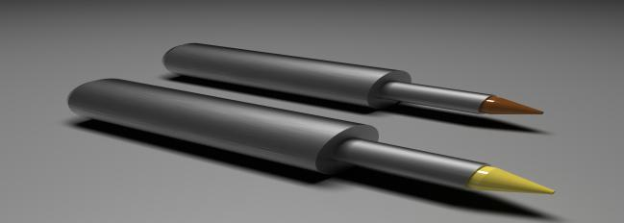

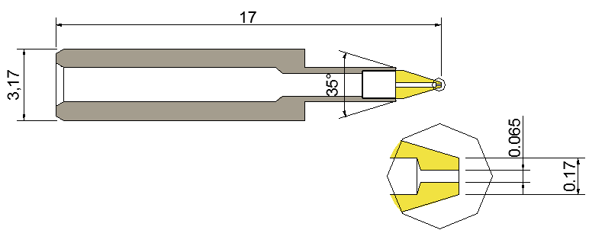

**技术参数**

|  |  |  |  |  |  |  |
| --- | --- | --- | --- | --- | --- | --- |
| NO | Part NO | OD | | ID | | 芯片范围 |
| inch | mm±0.005 | inch | mm±0.005 | inch |
| 1 | FY-025068-17A-Y-35-￠1.5 | 025 | 0.065 | 0.68 | 0.17 | 4.5～5.5 |
| 2 | FY-025068-17A-C-35-￠1.5 | 025 | 0.065 | 0.68 | 0.17 | 4.5～5.5 |
| 3 | FY-030072-17A-Y-35-￠1.5 | 030 | 0.075 | 0.72 | 0.18 | 5.5～6.5 |
| 4 | FY-030072-17A-C-35-￠1.5 | 030 | 0.075 | 0.72 | 0.18 | 5.5～6.5 |
| 5 | FY-035084-17A-Y-35-￠1.5 | 035 | 0.085 | 0.84 | 0.21 | 7～8 |
| 6 | FY-035084-17A-C-35-￠1.5 | 035 | 0.085 | 0.84 | 0.21 | 7～8 |
| 7 | FY-040092-17A-Y-35-￠1.5 | 040 | 0.1 | 0.92 | 0.23 | 8～9 |
| 8 | FY-040092-17A-C-35-￠1.5 | 040 | 0.1 | 0.92 | 0.23 | 8～9 |
| 9 | FY-050108-17A-Y-35-￠1.5 | 050 | 0.12 | 1.08 | 0.27 | 9～12 |
| 10 | FY-050108-17A-C-35-￠1.5 | 050 | 0.12 | 1.08 | 0.27 | 9～12 |
| 11 | FY-060120-17A-Y-35-￠1.5 | 060 | 0.15 | 1.2 | 0.3 | 12～14 |
| 12 | FY-060120-17A-C-35-￠1.5 | 060 | 0.15 | 1.2 | 0.3 | 12～14 |
| 13 | FY-080156-17A-Y-35-￠1.5 | 080 | 0.2 | 1.56 | 0.39 | 14～16 |
| 14 | FY-080156-17A-C-35-￠1.5 | 080 | 0.2 | 1.56 | 0.39 | 14～16 |
| 15 | FY-XXXXXX-17A-Y-35-￠1.5 | XXX | X.XX | X.XX | X.XX | XX～XX |
| 16 | FY-XXXXXX-17A-C-35-￠1.5 | XXX | X.XX | X.XX | X.XX | XX～XX |



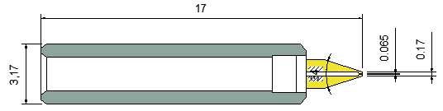

**技术参数**

|  |  |  |  |  |  |  |
| --- | --- | --- | --- | --- | --- | --- |
| NO | Part NO | OD | | ID | | 芯片范围 |
| inch | mm±0.005 | inch | mm±0.005 | inch |
| 1 | FY-025068-17A-Y-34-￠1.5 | 025 | 0.065 | 0.68 | 0.17 | 4.5～5.5 |
| 2 | FY-025068-17A-C-34-￠1.5 | 025 | 0.065 | 0.68 | 0.17 | 4.5～5.5 |
| 3 | FY-030072-17A-Y-34-￠1.5 | 030 | 0.075 | 0.72 | 0.18 | 5.5～6.5 |
| 4 | FY-030072-17A-C-34-￠1.5 | 030 | 0.075 | 0.72 | 0.18 | 5.5～6.5 |
| 5 | FY-035084-17A-Y-34-￠1.5 | 035 | 0.085 | 0.84 | 0.21 | 7～8 |
| 6 | FY-035084-17A-C-34-￠1.5 | 035 | 0.085 | 0.84 | 0.21 | 7～8 |
| 7 | FY-040092-17A-Y-34-￠1.5 | 040 | 0.1 | 0.92 | 0.23 | 8～9 |
| 8 | FY-040092-17A-C-34-￠1.5 | 040 | 0.1 | 0.92 | 0.23 | 8～9 |
| 9 | FY-050108-17A-Y-34-￠1.5 | 050 | 0.12 | 1.08 | 0.27 | 9～12 |
| 10 | FY-050108-17A-C-34-￠1.5 | 050 | 0.12 | 1.08 | 0.27 | 9～12 |
| 11 | FY-060120-17A-Y-34-￠1.5 | 060 | 0.15 | 1.2 | 0.3 | 12～14 |
| 12 | FY-060120-17A-C-34-￠1.5 | 060 | 0.15 | 1.2 | 0.3 | 12～14 |
| 13 | FY-080156-17A-Y-34-￠1.5 | 080 | 0.2 | 1.56 | 0.39 | 14～16 |
| 14 | FY-080156-17A-C-34-￠1.5 | 080 | 0.2 | 1.56 | 0.39 | 14～16 |
| 15 | FY-XXXXXX-17A-Y-34-￠1.5 | XXX | X.XX | X.XX | X.XX | XX～XX |
| 16 | FY-XXXXXX-17A-C-34-￠1.5 | XXX | X.XX | X.XX | X.XX | XX～XX |

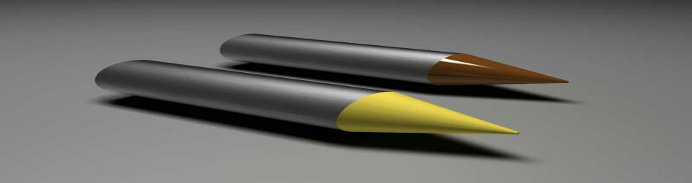

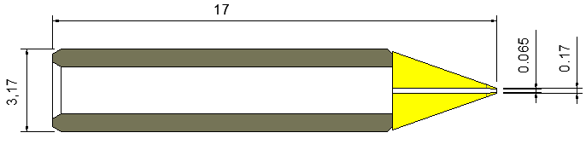

**技术参数**

|  |  |  |  |  |  |  |
| --- | --- | --- | --- | --- | --- | --- |
| NO | Part NO | OD | | ID | | 芯片范围 |
| inch | mm±0.005 | inch | mm±0.005 | inch |
| 1 | FY-025068-17A-Y-40 | 025 | 0.065 | 0.68 | 0.17 | 4.5～5.5 |
| 2 | FY-025068-17A-C-40 | 025 | 0.065 | 0.68 | 0.17 | 4.5～5.5 |
| 3 | FY-030072-17A-Y-40 | 030 | 0.075 | 0.72 | 0.18 | 5.5～6.5 |
| 4 | FY-030072-17A-C-40 | 030 | 0.075 | 0.72 | 0.18 | 5.5～6.5 |
| 5 | FY-035084-17A-Y-40 | 035 | 0.085 | 0.84 | 0.21 | 7～8 |
| 6 | FY-035084-17A-C-40 | 035 | 0.085 | 0.84 | 0.21 | 7～8 |
| 7 | FY-040092-17A-Y-40 | 040 | 0.1 | 0.92 | 0.23 | 8～9 |
| 8 | FY-040092-17A-C-40 | 040 | 0.1 | 0.92 | 0.23 | 8～9 |
| 9 | FY-050108-17A-Y-40 | 050 | 0.12 | 1.08 | 0.27 | 9～12 |
| 10 | FY-050108-17A-C-40 | 050 | 0.12 | 1.08 | 0.27 | 9～12 |
| 11 | FY-060120-17A-Y-40 | 060 | 0.15 | 1.2 | 0.3 | 12～14 |
| 12 | FY-060120-17A-C-40 | 060 | 0.15 | 1.2 | 0.3 | 12～14 |
| 13 | FY-080156-17A-Y-40 | 080 | 0.2 | 1.56 | 0.39 | 14～16 |
| 14 | FY-080156-17A-C-40 | 080 | 0.2 | 1.56 | 0.39 | 14～16 |
| 15 | FY-XXXXXX-17A-Y-40 | XXX | X.XX | X.XX | X.XX | XX～XX |
| 16 | FY-XXXXXX-17A-C-40 | XXX | X.XX | X.XX | X.XX | XX～XX |



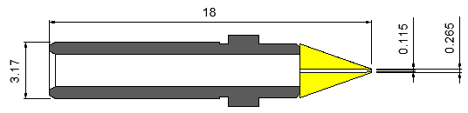

**技术参数**

|  |  |  |  |  |  |  |
| --- | --- | --- | --- | --- | --- | --- |
| NO | Part NO | OD | | ID | | 芯片范围 |
| inch | mm±0.005 | inch | mm±0.005 | inch |
| 1 | FY-025068-18B-Y-40光宝 | 025 | 0.065 | 0.68 | 0.17 | 4.5～5.5 |
| 2 | FY-025068-18B-C-40光宝 | 025 | 0.065 | 0.68 | 0.17 | 4.5～5.5 |
| 3 | FY-030072-18B-Y-40光宝 | 030 | 0.075 | 0.72 | 0.18 | 5.5～6.5 |
| 4 | FY-030072-18B-C-40光宝 | 030 | 0.075 | 0.72 | 0.18 | 5.5～6.5 |
| 5 | FY-035084-18B-Y-40光宝 | 035 | 0.085 | 0.84 | 0.21 | 7～8 |
| 6 | FY-035084-18B-C-40光宝 | 035 | 0.085 | 0.84 | 0.21 | 7～8 |
| 7 | FY-040092-18B-Y-40光宝 | 040 | 0.1 | 0.92 | 0.23 | 8～9 |
| 8 | FY-040092-18B-C-40光宝 | 040 | 0.1 | 0.92 | 0.23 | 8～9 |
| 9 | FY-050108-18B-Y-40光宝 | 050 | 0.12 | 1.08 | 0.27 | 9～12 |
| 10 | FY-050108-18B-C-40光宝 | 050 | 0.12 | 1.08 | 0.27 | 9～12 |
| 11 | FY-060120-18B-Y-40光宝 | 060 | 0.15 | 1.2 | 0.3 | 12～14 |
| 12 | FY-060120-18B-C-40光宝 | 060 | 0.15 | 1.2 | 0.3 | 12～14 |
| 13 | FY-080156-18B-Y-40光宝 | 080 | 0.2 | 1.56 | 0.39 | 14～16 |
| 14 | FY-080156-18B-C-40光宝 | 080 | 0.2 | 1.56 | 0.39 | 14～16 |
| 15 | FY-XXXXXX-18B-Y-40光宝 | XXX | X.XX | X.XX | X.XX | XX～XX |
| 16 | FY-XXXXXX-18B-C-40光宝 | XXX | X.XX | X.XX | X.XX | XX～XX |

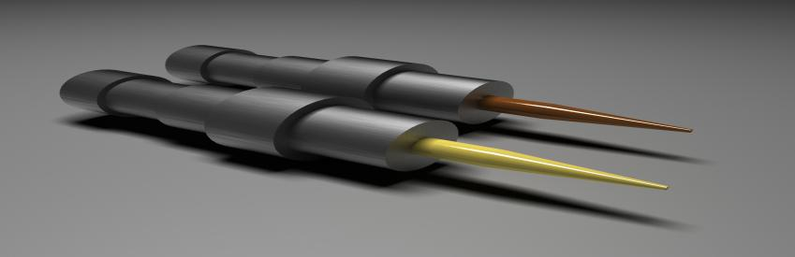

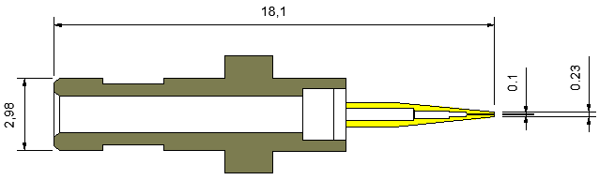

**技术参数**

|  |  |  |  |  |  |  |
| --- | --- | --- | --- | --- | --- | --- |
| NO | Part NO | OD | | ID | | 芯片范围 |
| inch | mm±0.005 | inch | mm±0.005 | inch |
| 1 | FY-025068-18.1B-Y-3.0-10-1.0 | 025 | 0.065 | 0.68 | 0.17 | 4.5～5.5 |
| 2 | FY-025068-18.1B-C-3.0-10-1.0 | 025 | 0.065 | 0.68 | 0.17 | 4.5～5.5 |
| 3 | FY-030072-18.1B-Y-3.0-10-1.0 | 030 | 0.075 | 0.72 | 0.18 | 5.5～6.5 |
| 4 | FY-030072-18.1B-C-3.0-10-1.0 | 030 | 0.075 | 0.72 | 0.18 | 5.5～6.5 |
| 5 | FY-035084-18.1B-Y-3.0-10-1.0 | 035 | 0.085 | 0.84 | 0.21 | 7～8 |
| 6 | FY-035084-18.1B-C-3.0-10-1.0 | 035 | 0.085 | 0.84 | 0.21 | 7～8 |
| 7 | FY-040092-18.1B-Y-3.0-10-1.0 | 040 | 0.1 | 0.92 | 0.23 | 8～9 |
| 8 | FY-040092-18.1B-C-3.0-10-1.0 | 040 | 0.1 | 0.92 | 0.23 | 8～9 |
| 9 | FY-050108-18.1B-Y-3.0-10-1.0 | 050 | 0.12 | 1.08 | 0.27 | 9～12 |
| 10 | FY-050108-18.1B-C-3.0-10-1.0 | 050 | 0.12 | 1.08 | 0.27 | 9～12 |
| 11 | FY-060120-18.1B-Y-3.0-10-1.0 | 060 | 0.15 | 1.2 | 0.3 | 12～14 |
| 12 | FY-060120-18.1B-C-3.0-10-1.0 | 060 | 0.15 | 1.2 | 0.3 | 12～14 |
| 13 | FY-080156-18.1B-Y-3.0-10-1.0 | 080 | 0.2 | 1.56 | 0.39 | 14～16 |
| 14 | FY-080156-18.1B-C-3.0-10-1.0 | 080 | 0.2 | 1.56 | 0.39 | 14～16 |
| 15 | FY-XXXXXX-18.1B-Y-3.0-10-1.0 | XXX | X.XX | X.XX | X.XX | XX～XX |
| 16 | FY-XXXXXX-18.1B-C-3.0-10-1.0 | XXX | X.XX | X.XX | X.XX | XX～XX |

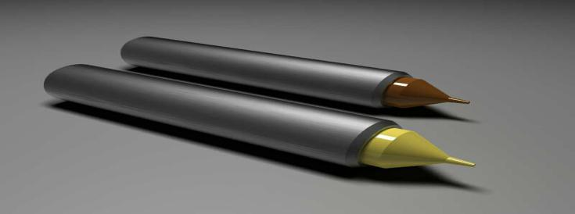

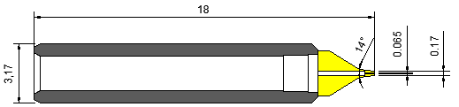

**技术参数**

|  |  |  |  |  |  |  |
| --- | --- | --- | --- | --- | --- | --- |
| NO | Part NO | OD | | ID | | 芯片范围 |
| inch | mm±0.005 | inch | mm±0.005 | inch |
| 1 | FY-025068-18A-Y-0.8-60 | 025 | 0.065 | 0.68 | 0.17 | 4.5～5.5 |
| 2 | FY-025068-18A-C-0.8-60 | 025 | 0.065 | 0.68 | 0.17 | 4.5～5.5 |
| 3 | FY-030072-18A-Y-0.8-60 | 030 | 0.075 | 0.72 | 0.18 | 5.5～6.5 |
| 4 | FY-030072-18A-C-0.8-60 | 030 | 0.075 | 0.72 | 0.18 | 5.5～6.5 |
| 5 | FY-035084-18A-Y-0.8-60 | 035 | 0.085 | 0.84 | 0.21 | 7～8 |
| 6 | FY-035084-18A-C-0.8-60 | 035 | 0.085 | 0.84 | 0.21 | 7～8 |
| 7 | FY-040092-18A-Y-0.8-60 | 040 | 0.1 | 0.92 | 0.23 | 8～9 |
| 8 | FY-040092-18A-C-0.8-60 | 040 | 0.1 | 0.92 | 0.23 | 8～9 |
| 9 | FY-050108-18A-Y-0.8-60 | 050 | 0.12 | 1.08 | 0.27 | 9～12 |
| 10 | FY-050108-18A-C-0.8-60 | 050 | 0.12 | 1.08 | 0.27 | 9～12 |
| 11 | FY-060120-18A-Y-0.8-60 | 060 | 0.15 | 1.2 | 0.3 | 12～14 |
| 12 | FY-060120-18A-C-0.8-60 | 060 | 0.15 | 1.2 | 0.3 | 12～14 |
| 13 | FY-080156-18A-Y-0.8-60 | 080 | 0.2 | 1.56 | 0.39 | 14～16 |
| 14 | FY-080156-18A-C-0.8-60 | 080 | 0.2 | 1.56 | 0.39 | 14～16 |
| 15 | FY-XXXXXX-18A-Y-0.8-60 | XXX | X.XX | X.XX | X.XX | XX～XX |
| 16 | FY-XXXXXX-18A-C-0.8-60 | XXX | X.XX | X.XX | X.XX | XX～XX |

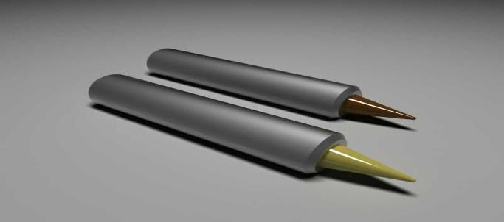

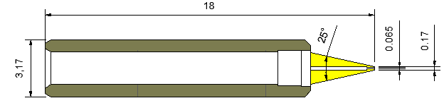

**技术参数**

|  |  |  |  |  |  |  |
| --- | --- | --- | --- | --- | --- | --- |
| NO | Part NO | OD | | ID | | 芯片范围 |
| inch | mm±0.005 | inch | mm±0.005 | inch |
| 1 | FY-025068-18A-Y-25 | 025 | 0.065 | 0.68 | 0.17 | 4.5～5.5 |
| 2 | FY-025068-18A-C-25 | 025 | 0.065 | 0.68 | 0.17 | 4.5～5.5 |
| 3 | FY-030072-18A-Y-25 | 030 | 0.075 | 0.72 | 0.18 | 5.5～6.5 |
| 4 | FY-030072-18A-C-25 | 030 | 0.075 | 0.72 | 0.18 | 5.5～6.5 |
| 5 | FY-035084-18A-Y-25 | 035 | 0.085 | 0.84 | 0.21 | 7～8 |
| 6 | FY-035084-18A-C-25 | 035 | 0.085 | 0.84 | 0.21 | 7～8 |
| 7 | FY-040092-18A-Y-25 | 040 | 0.1 | 0.92 | 0.23 | 8～9 |
| 8 | FY-040092-18A-C-25 | 040 | 0.1 | 0.92 | 0.23 | 8～9 |
| 9 | FY-050108-18A-Y-25 | 050 | 0.12 | 1.08 | 0.27 | 9～12 |
| 10 | FY-050108-18A-C-25 | 050 | 0.12 | 1.08 | 0.27 | 9～12 |
| 11 | FY-060120-18A-Y-25 | 060 | 0.15 | 1.2 | 0.3 | 12～14 |
| 12 | FY-060120-18A-C-25 | 060 | 0.15 | 1.2 | 0.3 | 12～14 |
| 13 | FY-080156-18A-Y-25 | 080 | 0.2 | 1.56 | 0.39 | 14～16 |
| 14 | FY-080156-18A-C-25 | 080 | 0.2 | 1.56 | 0.39 | 14～16 |
| 15 | FY-XXXXXX-18A-Y-25 | XXX | X.XX | X.XX | X.XX | XX～XX |
| 16 | FY-XXXXXX-18A-C-25 | XXX | X.XX | X.XX | X.XX | XX～XX |

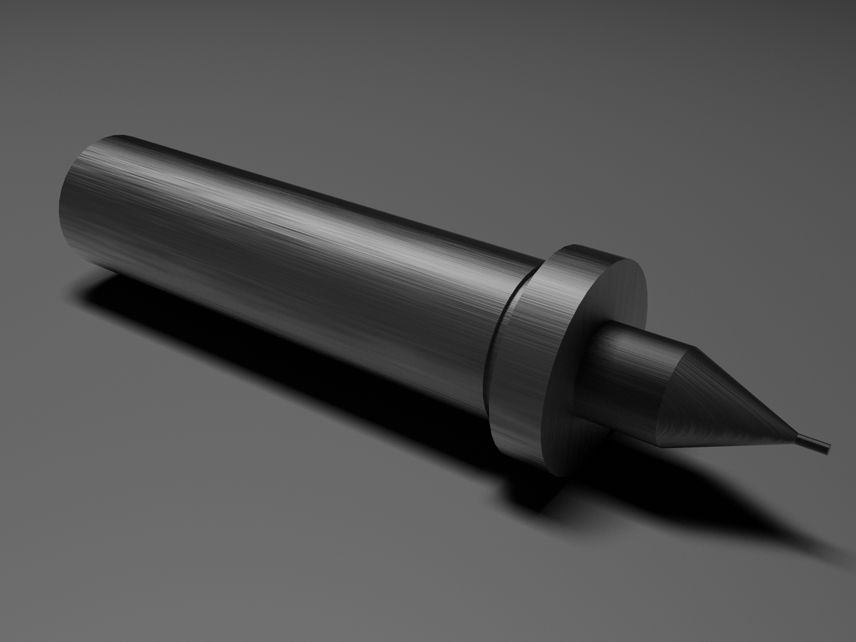

名称：陶瓷吸嘴

材质：陶瓷

产品概述：陶瓷吸嘴是以陶瓷为材料、吸嘴形、通过密封管泵吸去空气使 吸 嘴 吸 住 物品从而达到 搬运 效 果 的 器 具。相 对 于其 他 机 械 搬 运 方 式，陶 瓷 吸 嘴 能 在 不 伤 害 产 品 或原材料的前提下完成整个运送过程。

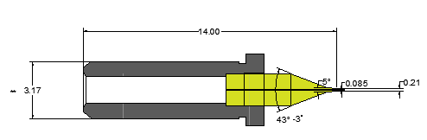

**技术参数**

|  |  |  |  |  |  |  |
| --- | --- | --- | --- | --- | --- | --- |
| NO | Part NO | OD | | ID | | 芯片范围 |
| inch | mm±0.005 | inch | mm±0.005 | inch |
| 1 | FY-025068-14B-B-P10 | 025 | 0.065 | 0.68 | 0.17 | 4.5～5.5 |
| 2 | FY-030072-14B-B-P10 | 030 | 0.075 | 0.72 | 0.18 | 5.5～6.5 |
| 3 | FY-035084-14B-B-P10 | 035 | 0.085 | 0.84 | 0.21 | 7～8 |
| 4 | FY-040092-14B-B-P10 | 040 | 0.1 | 0.92 | 0.23 | 8～9 |
| 5 | FY-050108-14B-B-P10 | 050 | 0.12 | 1.08 | 0.27 | 9～12 |
| 6 | FY-060120-14B-B-P10 | 060 | 0.15 | 1.2 | 0.3 | 12～14 |
| 7 | FY-080156-14B-B-P10 | 080 | 0.2 | 1.56 | 0.39 | 14～16 |
| 8 | FY-XXXXXX-14B-B-P10 | XXX | X.XX | X.XX | X.XX | XX～XX |



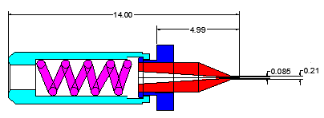

**技术参数**

|  |  |  |  |  |  |  |
| --- | --- | --- | --- | --- | --- | --- |
| NO | Part NO | OD | | ID | | 芯片范围 |
| inch | mm±0.005 | inch | mm±0.005 | inch |
| 1 | FY-025068-14B-B-P10 | 025 | 0.065 | 0.68 | 0.17 | 4.5～5.5 |
| 2 | FY-030072-14B-B-P10 | 030 | 0.075 | 0.72 | 0.18 | 5.5～6.5 |
| 3 | FY-035084-14B-B-P10 | 035 | 0.085 | 0.84 | 0.21 | 7～8 |
| 4 | FY-040092-14B-B-P10 | 040 | 0.1 | 0.92 | 0.23 | 8～9 |
| 5 | FY-050108-14B-B-P10 | 050 | 0.12 | 1.08 | 0.27 | 9～12 |
| 6 | FY-060120-14B-B-P10 | 060 | 0.15 | 1.2 | 0.3 | 12～14 |
| 7 | FY-080156-14B-B-P10 | 080 | 0.2 | 1.56 | 0.39 | 14～16 |
| 8 | FY-XXXXXX-14B-B-P10 | XXX | X.XX | X.XX | X.XX | XX～XX |



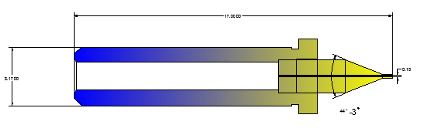

**技术参数**

|  |  |  |  |  |  |  |
| --- | --- | --- | --- | --- | --- | --- |
| NO | Part NO | OD | | ID | | 芯片范围 |
| inch | mm±0.005 | inch | mm±0.005 | inch |
| 1 | FY-025068-17B-B-P10 | 025 | 0.065 | 0.68 | 0.17 | 4.5～5.5 |
| 2 | FY-030072-17B-B-P10 | 030 | 0.075 | 0.72 | 0.18 | 5.5～6.5 |
| 3 | FY-035084-17B-B-P10 | 035 | 0.085 | 0.84 | 0.21 | 7～8 |
| 4 | FY-040092-17B-B-P10 | 040 | 0.1 | 0.92 | 0.23 | 8～9 |
| 5 | FY-050108-17B-B-P10 | 050 | 0.12 | 1.08 | 0.27 | 9～12 |
| 6 | FY-060120-17B-B-P10 | 060 | 0.15 | 1.2 | 0.3 | 12～14 |
| 7 | FY-080156-17B-B-P10 | 080 | 0.2 | 1.56 | 0.39 | 14～16 |
| 8 | FY-XXXXXX-17B-B-P10 | XXX | X.XX | X.XX | X.XX | XX～XX |

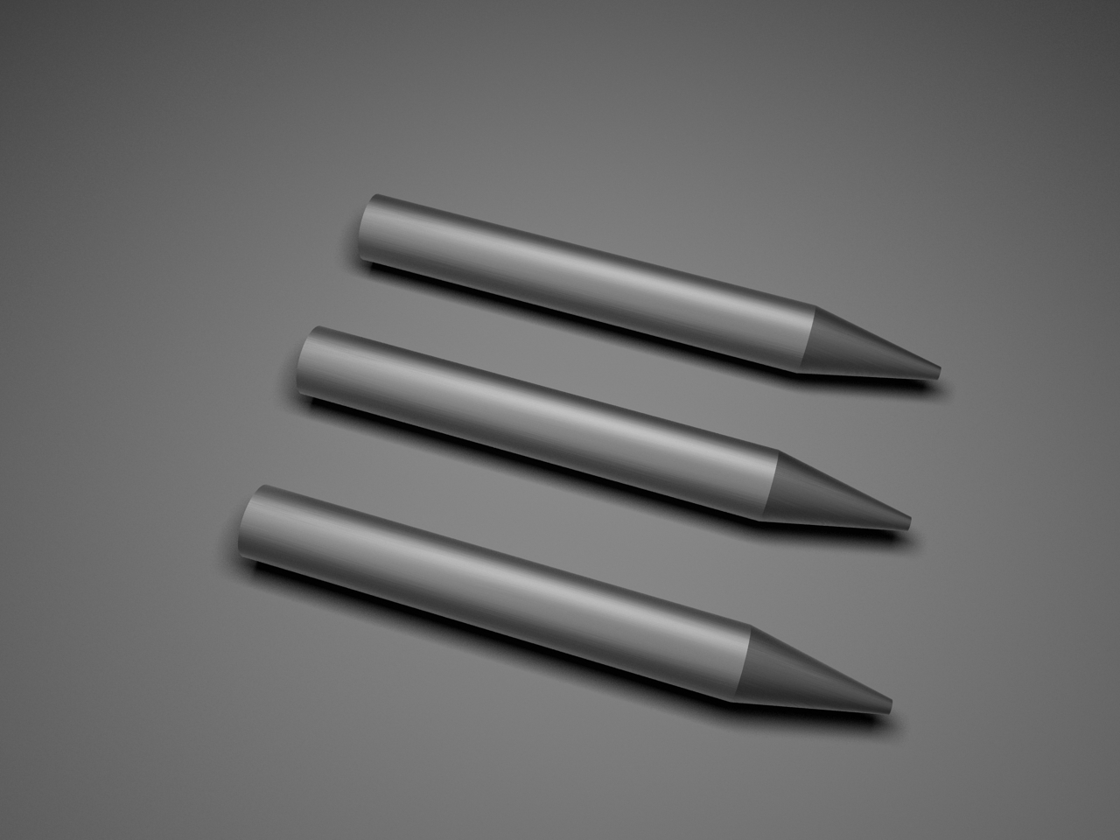名称：顶针

材质：钨钢

产品概述：

钨钢顶针--材质为钨钢，通过精密设备研磨而成，目前使用在光电行业，尖部角度控制在8°、10°、15°、20°、30°之间，主要用于自动固晶机设备上，支撑（向上顶）辅助真空吸附系统。

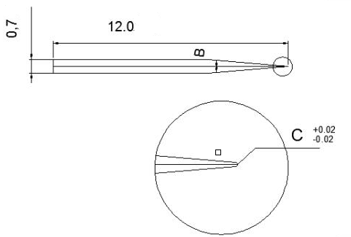

**技术参数**

|  |  |  |  |  |  |
| --- | --- | --- | --- | --- | --- |
| NO | Part No | L/D | A | R | 芯片范围 |
| mm | ° | mm | inch |
| 1 | FY-12-007-08-0015-P20 | 20/007 | 8 | 0.015 | 4.5～6.5 |
| 2 | FY-12-007-08-0018-P20 | 20/007 | 8 | 0.018 | 6.5～8 |
| 3 | FY-12-007-08-0020-P20 | 20/007 | 8 | 0.02 | 8～10 |
| 4 | FY-12-007-08-0022-P20 | 20/007 | 8 | 0.022 | 10～15 |
| 5 | FY-12-007-10-0015-P20 | 20/007 | 10 | 0.015 | 4.5～6.5 |
| 6 | FY-12-007-10-0018-P20 | 20/007 | 10 | 0.018 | 6.5～8 |
| 7 | FY-12-007-10-0020-P20 | 20/007 | 10 | 0.02 | 8～10 |
| 8 | FY-12-007-10-0022-P20 | 20/007 | 10 | 0.022 | 10～15 |
| 9 | FY-12-007-10-0024-P20 | 20/007 | 10 | 0.024 | 15～20 |
| 10 | FY-12-007-15-0022-P20 | 20/007 | 15 | 0.022 | 10～15 |
| 11 | FY-12-007-15-0024-P20 | 20/007 | 15 | 0.024 | 15～20 |
| 12 | FY-12-007-15-XXXX-P20 | 20/007 | 15 | X.XXX | 20以上 |
| 13 | FY-12-007-20-0025-P20 | 20/007 | 20 | 0.025 | 15～20 |
| 14 | FY-12-007-20-0030-P20 | 20/007 | 20 | 0.03 | 25以上 |
| 15 | FY-12-007-XX-XXXX-P20 | 20/007 | XX | X.XXX | XX～XX |



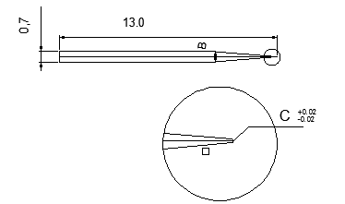

**技术参数**

|  |  |  |  |  |  |
| --- | --- | --- | --- | --- | --- |
| NO | Part No | L/D | A | R | 芯片范围 |
| mm | ° | mm | inch |
| 1 | FY-13-007-08-0015-P20 | 17/007 | 8 | 0.015 | 4.5～6.5 |
| 2 | FY-13-007-08-0018-P20 | 17/007 | 8 | 0.018 | 6.5～8 |
| 3 | FY-13-007-08-0020-P20 | 17/007 | 8 | 0.02 | 8～10 |
| 4 | FY-13-007-08-0022-P20 | 17/007 | 8 | 0.022 | 10～15 |
| 5 | FY-13-007-10-0015-P20 | 17/007 | 10 | 0.015 | 4.5～6.5 |
| 6 | FY-13-007-10-0018-P20 | 17/007 | 10 | 0.018 | 6.5～8 |
| 7 | FY-13-007-10-0020-P20 | 17/007 | 10 | 0.02 | 8～10 |
| 8 | FY-13-007-10-0022-P20 | 17/007 | 10 | 0.022 | 10～15 |
| 9 | FY-13-007-10-0024-P20 | 17/007 | 10 | 0.024 | 15～20 |
| 10 | FY-13-007-15-0022-P20 | 17/007 | 15 | 0.022 | 10～15 |
| 11 | FY-13-007-15-0024-P20 | 17/007 | 15 | 0.024 | 15～20 |
| 12 | FY-13-007-15-XXXX-P20 | 17/007 | 15 | X.XXX | 20以上 |
| 13 | FY-13-007-20-0025-P20 | 17/007 | 20 | 0.025 | 15～20 |
| 14 | FY-13-007-20-0030-P20 | 17/007 | 20 | 0.03 | 25以上 |
| 15 | FY-13-007-XX-XXXX-P20 | 17/007 | XX | X.XXX | XX～XX |

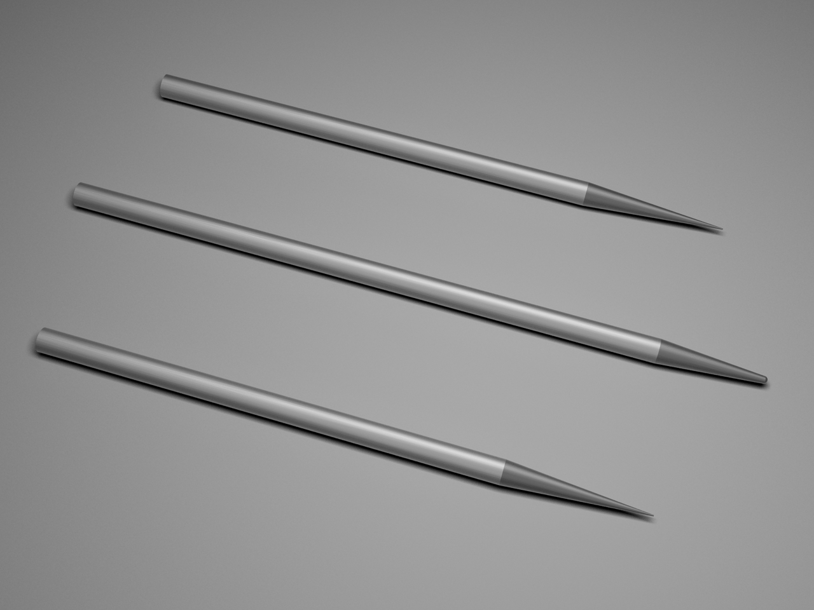

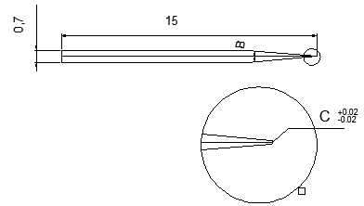

**技术参数**

|  |  |  |  |  |  |
| --- | --- | --- | --- | --- | --- |
| NO | Part No | L/D | A | R | 芯片范围 |
| mm | ° | mm | inch |
| 1 | FY-15-005-08-0015-P20 | 15/005 | 8 | 0.015 | 4.5～6.5 |
| 2 | FY-15-005-08-0018-P20 | 15/005 | 8 | 0.018 | 6.5～8 |
| 3 | FY-15-005-08-0020-P20 | 15/005 | 8 | 0.02 | 8～10 |
| 4 | FY-15-005-08-0022-P20 | 15/005 | 8 | 0.022 | 10～15 |
| 5 | FY-15-005-10-0015-P20 | 15/005 | 10 | 0.015 | 4.5～6.5 |
| 6 | FY-15-005-10-0018-P20 | 15/005 | 10 | 0.018 | 6.5～8 |
| 7 | FY-15-005-10-0020-P20 | 15/005 | 10 | 0.02 | 8～10 |
| 8 | FY-15-005-10-0022-P20 | 15/005 | 10 | 0.022 | 10～15 |
| 9 | FY-15-005-10-0024-P20 | 15/005 | 10 | 0.024 | 15～20 |
| 10 | FY-15-005-15-0022-P20 | 15/005 | 15 | 0.022 | 10～15 |
| 11 | FY-15-005-15-0024-P20 | 15/005 | 15 | 0.024 | 15～20 |
| 12 | FY-15-005-15-XXXX-P20 | 15/005 | 15 | X.XXX | 20以上 |
| 13 | FY-15-005-20-0025-P20 | 15/005 | 20 | 0.025 | 15～20 |
| 14 | FY-15-005-20-0030-P20 | 15/005 | 20 | 0.03 | 25以上 |
| 15 | FY-15-005-XX-XXXX-P20 | 15/005 | XX | X.XXX | XX～XX |



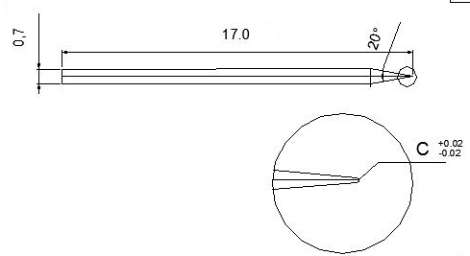

**技术参数**

|  |  |  |  |  |  |
| --- | --- | --- | --- | --- | --- |
| NO | Part No | L/D | A | R | 芯片范围 |
| mm | ° | mm | inch |
| 1 | FY-17-007-08-0015-P20 | 17/007 | 8 | 0.015 | 4.5～6.5 |
| 2 | FY-17-007-08-0018-P20 | 17/007 | 8 | 0.018 | 6.5～8 |
| 3 | FY-17-007-08-0020-P20 | 17/007 | 8 | 0.02 | 8～10 |
| 4 | FY-17-007-08-0022-P20 | 17/007 | 8 | 0.022 | 10～15 |
| 5 | FY-17-007-10-0015-P20 | 17/007 | 10 | 0.015 | 4.5～6.5 |
| 6 | FY-17-007-10-0018-P20 | 17/007 | 10 | 0.018 | 6.5～8 |
| 7 | FY-17-007-10-0020-P20 | 17/007 | 10 | 0.02 | 8～10 |
| 8 | FY-17-007-10-0022-P20 | 17/007 | 10 | 0.022 | 10～15 |
| 9 | FY-17-007-10-0024-P20 | 17/007 | 10 | 0.024 | 15～20 |
| 10 | FY-17-007-15-0022-P20 | 17/007 | 15 | 0.022 | 10～15 |
| 11 | FY-17-007-15-0024-P20 | 17/007 | 15 | 0.024 | 15～20 |
| 12 | FY-17-007-15-XXXX-P20 | 17/007 | 15 | X.XXX | 20以上 |
| 13 | FY-17-007-20-0025-P20 | 17/007 | 20 | 0.025 | 15～20 |
| 14 | FY-17-007-20-0030-P20 | 17/007 | 20 | 0.03 | 25以上 |
| 15 | FY-17-007-XX-XXXX-P20 | 17/007 | XX | X.XXX | XX～XX |

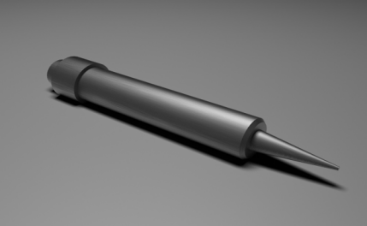**名称：点胶头**

**材质：进口高速钢**

**产品概述：**

**接触式点胶针，又名粘胶式点胶针，采用进口高速钢材质，可由精准度、粘度以及顾客指定用途来选择合适的产品**

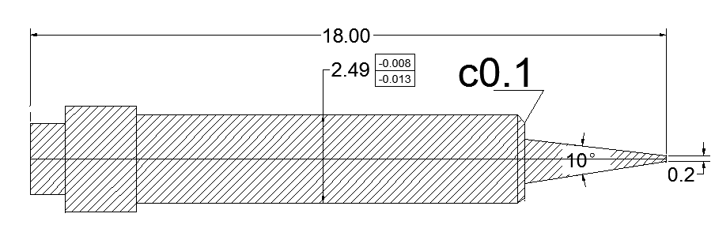

**技术参数**

|  |  |  |  |  |  |  |  |  |
| --- | --- | --- | --- | --- | --- | --- | --- | --- |
| NO | Part No | ￠A | | ￠B | | ￠C | | 芯片范围 |
| inch | mm | inch | mm | inch | mm | inch |
| 1 | FY-18-2.5-10-0.25-0.10 | 0.010 | 0.254 | 0.004 | 0.102 | 0.004 | 0.102 | 7～8 |
| 2 | FY-18-2.5-10-0.30-0.10 | 0.012 | 0.305 | 0.004 | 0.102 | 0.004 | 0.102 | 7～9 |
| 3 | FY-18-2.5-10-0.30-0.15 | 0.012 | 0.305 | 0.006 | 0.152 | 0.004 | 0.102 | 7～10 |
| 4 | FY-18-2.5-10-0.35-0.10 | 0.014 | 0.356 | 0.004 | 0.102 | 0.004 | 0.102 | 7～11 |
| 5 | FY-18-2.5-10-0.35-0.15 | 0.014 | 0.356 | 0.006 | 0.152 | 0.004 | 0.102 | 7～12 |
| 6 | FY-18-2.5-10-0.40-0.15 | 0.020 | 0.500 | 0.006 | 0.152 | 0.004 | 0.102 | 7～13 |
| 7 | FY-18-2.5-10-0.40-0.20 | 0.020 | 0.500 | 0.008 | 0.204 | 0.004 | 0.102 | 7～14 |
| 8 | FY-18-2.5-10-0.50-0.15 | 0.025 | 0.100 | 0.006 | 0.152 | 0.004 | 0.102 | 7～15 |
| 9 | FY-18-2.5-10-0.50-0.20 | 0.025 | 0.100 | 0.008 | 0.204 | 0.004 | 0.102 | 9～12 |
| 10 | FY-18-2.5-10-X.XX-X.xx | x.xxx | x.xxx | x.xxx | x.xxx | 0.004 | 0.102 | xx～xx |

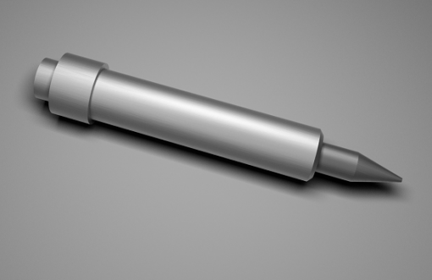

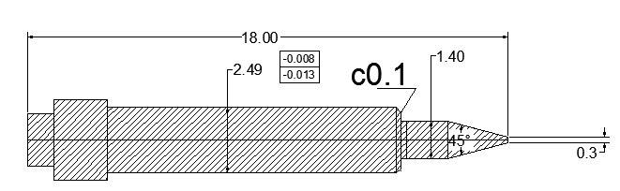

**技术参数**

|  |  |  |  |  |  |  |  |  |
| --- | --- | --- | --- | --- | --- | --- | --- | --- |
| NO | Part No | ￠A | | ￠B | | ￠C | | 芯片范围 |
| inch | mm | inch | mm | inch | mm | inch |
| 1 | FY-18-2.5-45-0.25-0.10 | 0.010 | 0.254 | 0.004 | 0.102 | 0.004 | 0.102 | 7～8 |
| 2 | FY-18-2.5-45-0.30-0.10 | 0.012 | 0.305 | 0.004 | 0.102 | 0.004 | 0.102 | 7～9 |
| 3 | FY-18-2.5-45-0.30-0.15 | 0.012 | 0.305 | 0.006 | 0.152 | 0.004 | 0.102 | 7～10 |
| 4 | FY-18-2.5-45-0.35-0.10 | 0.014 | 0.356 | 0.004 | 0.102 | 0.004 | 0.102 | 7～11 |
| 5 | FY-18-2.5-45-0.35-0.15 | 0.014 | 0.356 | 0.006 | 0.152 | 0.004 | 0.102 | 7～12 |
| 6 | FY-18-2.5-45-0.40-0.15 | 0.020 | 0.500 | 0.006 | 0.152 | 0.004 | 0.102 | 7～13 |
| 7 | FY-18-2.5-45-0.40-0.20 | 0.020 | 0.500 | 0.008 | 0.204 | 0.004 | 0.102 | 7～14 |
| 8 | FY-18-2.5-45-0.50-0.15 | 0.025 | 0.100 | 0.006 | 0.152 | 0.004 | 0.102 | 7～15 |
| 9 | FY-18-2.5-45-0.50-0.20 | 0.025 | 0.100 | 0.008 | 0.204 | 0.004 | 0.102 | 9～12 |
| 10 | FY-18-2.5-45-X.XX-X.xx | x.xxx | x.xxx | x.xxx | x.xxx | 0.004 | 0.102 | xx～xx |

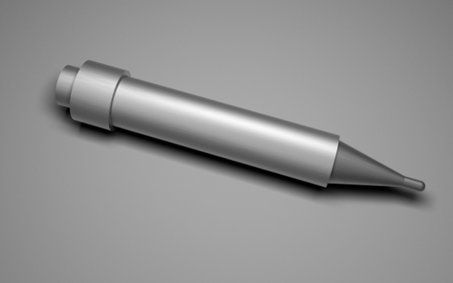

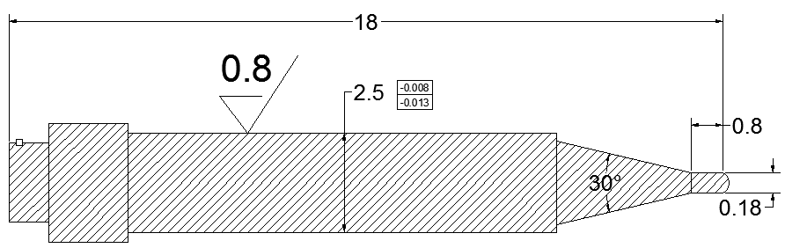

**技术参数**

|  |  |  |  |  |  |  |  |  |
| --- | --- | --- | --- | --- | --- | --- | --- | --- |
| NO | Part No | ￠A | | ￠B | | ￠C | | 芯片范围 |
| inch | mm | inch | mm | inch | mm | inch |
| 1 | FY-18-2.5-30-0.25-0.10 | 0.010 | 0.254 | 0.004 | 0.102 | 0.004 | 0.102 | 7～8 |
| 2 | FY-18-2.5-30-0.30-0.10 | 0.012 | 0.305 | 0.004 | 0.102 | 0.004 | 0.102 | 7～9 |
| 3 | FY-18-2.5-30-0.30-0.15 | 0.012 | 0.305 | 0.006 | 0.152 | 0.004 | 0.102 | 7～10 |
| 4 | FY-18-2.5-30-0.35-0.10 | 0.014 | 0.356 | 0.004 | 0.102 | 0.004 | 0.102 | 7～11 |
| 5 | FY-18-2.5-30-0.35-0.15 | 0.014 | 0.356 | 0.006 | 0.152 | 0.004 | 0.102 | 7～12 |
| 6 | FY-18-2.5-30-0.40-0.15 | 0.020 | 0.500 | 0.006 | 0.152 | 0.004 | 0.102 | 7～13 |
| 7 | FY-18-2.5-30-0.40-0.20 | 0.020 | 0.500 | 0.008 | 0.204 | 0.004 | 0.102 | 7～14 |
| 8 | FY-18-2.5-30-0.50-0.15 | 0.025 | 0.100 | 0.006 | 0.152 | 0.004 | 0.102 | 7～15 |
| 9 | FY-18-2.5-30-0.50-0.20 | 0.025 | 0.100 | 0.008 | 0.204 | 0.004 | 0.102 | 9～12 |
| 10 | FY-18-2.5-30-X.XX-X.xx | x.xxx | x.xxx | x.xxx | x.xxx | 0.004 | 0.102 | xx～xx |

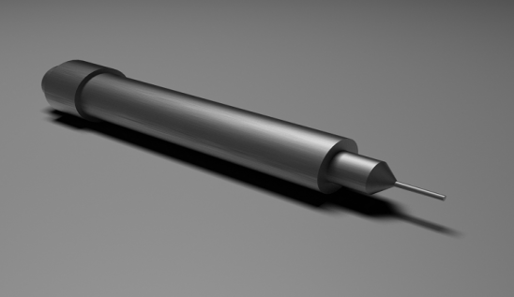

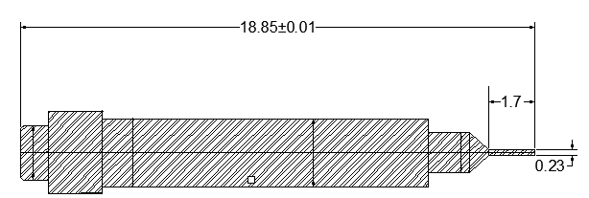

**技术参数**

|  |  |  |  |  |  |  |  |  |
| --- | --- | --- | --- | --- | --- | --- | --- | --- |
| NO | Part No | ￠A | | ￠B | | ￠C | | 芯片范围 |
| inch | mm | inch | mm | inch | mm | inch |
| 1 | FY-18.85-2.5-45-0.25-0.10 | 0.010 | 0.254 | 0.004 | 0.102 | 0.004 | 0.102 | 7～8 |
| 2 | FY-18.85-2.5-45-0.30-0.10 | 0.012 | 0.305 | 0.004 | 0.102 | 0.004 | 0.102 | 7～9 |
| 3 | FY-18.85-2.5-45-0.30-0.15 | 0.012 | 0.305 | 0.006 | 0.152 | 0.004 | 0.102 | 7～10 |
| 4 | FY-18.85-2.5-45-0.35-0.10 | 0.014 | 0.356 | 0.004 | 0.102 | 0.004 | 0.102 | 7～11 |
| 5 | FY-18.85-2.5-45-0.35-0.15 | 0.014 | 0.356 | 0.006 | 0.152 | 0.004 | 0.102 | 7～12 |
| 6 | FY-18.85-2.5-45-0.40-0.15 | 0.020 | 0.500 | 0.006 | 0.152 | 0.004 | 0.102 | 7～13 |
| 7 | FY-18.85-2.5-45-0.40-0.20 | 0.020 | 0.500 | 0.008 | 0.204 | 0.004 | 0.102 | 7～14 |
| 8 | FY-18.85-2.5-45-0.50-0.15 | 0.025 | 0.100 | 0.006 | 0.152 | 0.004 | 0.102 | 7～15 |
| 9 | FY-18.85-2.5-45-0.50-0.20 | 0.025 | 0.100 | 0.008 | 0.204 | 0.004 | 0.102 | 9～12 |
| 10 | FY-18.85-2.5-45-X.XX-X.xx | x.xxx | x.xxx | x.xxx | x.xxx | 0.004 | 0.102 | xx～xx |

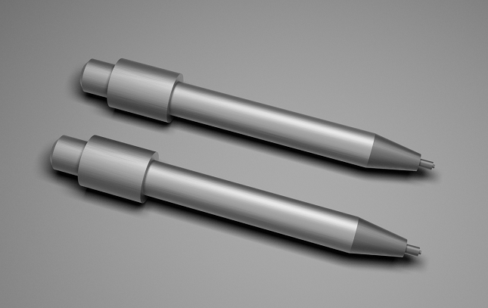

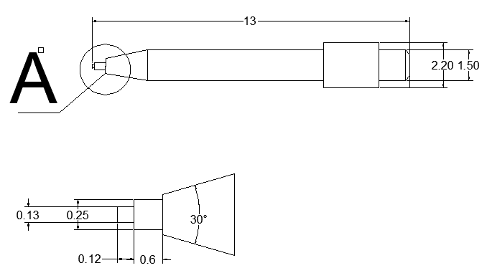

**技术参数**

|  |  |  |  |  |  |  |  |  |
| --- | --- | --- | --- | --- | --- | --- | --- | --- |
| NO | Part No | ￠A | | ￠B | | ￠C | | 芯片范围 |
| inch | mm | inch | mm | inch | mm | inch |
| 1 | FY-13-1.5-30-0.25-0.10 | 0.010 | 0.254 | 0.004 | 0.102 | 0.004 | 0.102 | 7～8 |
| 2 | FY-13-1.5-30-0.30-0.10 | 0.012 | 0.305 | 0.004 | 0.102 | 0.004 | 0.102 | 7～9 |
| 3 | FY-13-1.5-30-0.30-0.15 | 0.012 | 0.305 | 0.006 | 0.152 | 0.004 | 0.102 | 7～10 |
| 4 | FY-13-1.5-30-0.35-0.10 | 0.014 | 0.356 | 0.004 | 0.102 | 0.004 | 0.102 | 7～11 |
| 5 | FY-13-1.5-30-0.35-0.15 | 0.014 | 0.356 | 0.006 | 0.152 | 0.004 | 0.102 | 7～12 |
| 6 | FY-13-1.5-30-0.40-0.15 | 0.020 | 0.500 | 0.006 | 0.152 | 0.004 | 0.102 | 7～13 |
| 7 | FY-13-1.5-30-0.40-0.20 | 0.020 | 0.500 | 0.008 | 0.204 | 0.004 | 0.102 | 7～14 |
| 8 | FY-13-1.5-30-0.50-0.15 | 0.025 | 0.100 | 0.006 | 0.152 | 0.004 | 0.102 | 7～15 |
| 9 | FY-13-1.5-30-0.50-0.20 | 0.025 | 0.100 | 0.008 | 0.204 | 0.004 | 0.102 | 9～12 |
| 10 | FY-13-1.5-30-X.XX-X.xx | x.xxx | x.xxx | x.xxx | x.xxx | 0.004 | 0.102 | xx～xx |

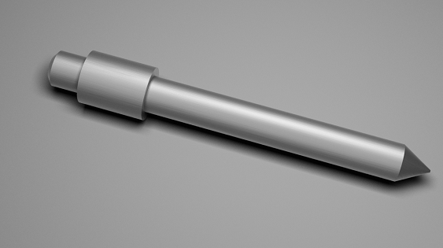

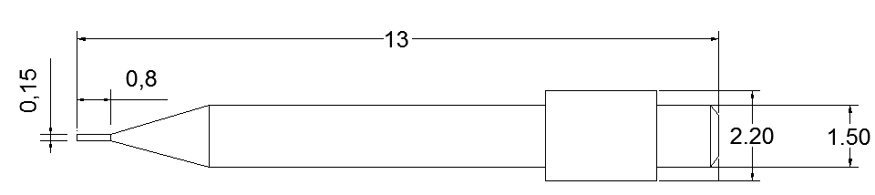

**技术参数**

|  |  |  |  |  |  |  |  |  |
| --- | --- | --- | --- | --- | --- | --- | --- | --- |
| NO | Part No | ￠A | | ￠B | | ￠C | | 芯片范围 |
| inch | mm | inch | mm | inch | mm | inch |
| 1 | FY-13-1.5-60-0.25-0.10 | 0.010 | 0.254 | 0.004 | 0.102 | 0.004 | 0.102 | 7～8 |
| 2 | FY-13-1.5-60-0.30-0.10 | 0.012 | 0.305 | 0.004 | 0.102 | 0.004 | 0.102 | 7～9 |
| 3 | FY-13-1.5-60-0.30-0.15 | 0.012 | 0.305 | 0.006 | 0.152 | 0.004 | 0.102 | 7～10 |
| 4 | FY-13-1.5-60-0.35-0.10 | 0.014 | 0.356 | 0.004 | 0.102 | 0.004 | 0.102 | 7～11 |
| 5 | FY-13-1.5-60-0.35-0.15 | 0.014 | 0.356 | 0.006 | 0.152 | 0.004 | 0.102 | 7～12 |
| 6 | FY-13-1.5-60-0.40-0.15 | 0.020 | 0.500 | 0.006 | 0.152 | 0.004 | 0.102 | 7～13 |
| 7 | FY-13-1.5-60-0.40-0.20 | 0.020 | 0.500 | 0.008 | 0.204 | 0.004 | 0.102 | 7～14 |
| 8 | FY-13-1.5-60-0.50-0.15 | 0.025 | 0.100 | 0.006 | 0.152 | 0.004 | 0.102 | 7～15 |
| 9 | FY-13-1.5-60-0.50-0.20 | 0.025 | 0.100 | 0.008 | 0.204 | 0.004 | 0.102 | 9～12 |
| 10 | FY-13-1.5-60-X.XX-X.xx | x.xxx | x.xxx | x.xxx | x.xxx | 0.004 | 0.102 | xx～xx |

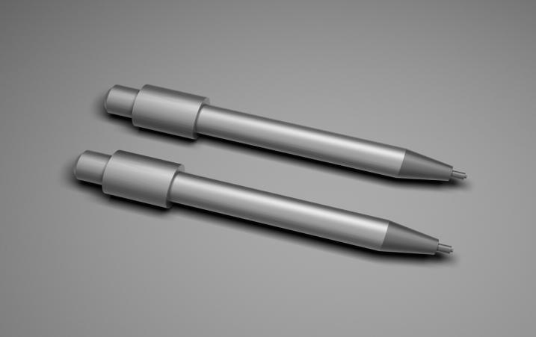

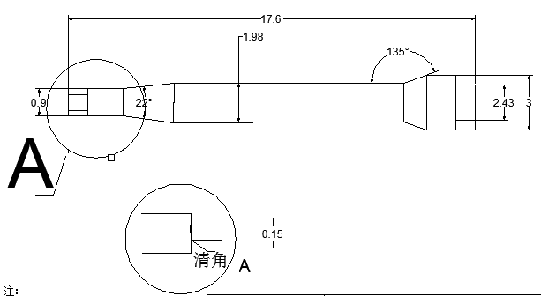

**技术参数**

|  |  |  |  |  |  |  |  |  |
| --- | --- | --- | --- | --- | --- | --- | --- | --- |
| NO | Part No | ￠A | | ￠B | | ￠C | | 芯片范围 |
| inch | mm | inch | mm | inch | mm | inch |
| 1 | FY-17.6-2-22-0.25-0.10 | 0.010 | 0.254 | 0.004 | 0.102 | 0.004 | 0.102 | 7～8 |
| 2 | FY-17.6-2-22-0.30-0.10 | 0.012 | 0.305 | 0.004 | 0.102 | 0.004 | 0.102 | 7～9 |
| 3 | FY-17.6-2-22-0.30-0.15 | 0.012 | 0.305 | 0.006 | 0.152 | 0.004 | 0.102 | 7～10 |
| 4 | FY-17.6-2-22-0.35-0.10 | 0.014 | 0.356 | 0.004 | 0.102 | 0.004 | 0.102 | 7～11 |
| 5 | FY-17.6-2-22-0.35-0.15 | 0.014 | 0.356 | 0.006 | 0.152 | 0.004 | 0.102 | 7～12 |
| 6 | FY-17.6-2-22-0.40-0.15 | 0.020 | 0.500 | 0.006 | 0.152 | 0.004 | 0.102 | 7～13 |
| 7 | FY-17.6-2-22-0.40-0.20 | 0.020 | 0.500 | 0.008 | 0.204 | 0.004 | 0.102 | 7～14 |
| 8 | FY-17.6-2-22-0.50-0.15 | 0.025 | 0.100 | 0.006 | 0.152 | 0.004 | 0.102 | 7～15 |
| 9 | FY-17.6-2-22-0.50-0.20 | 0.025 | 0.100 | 0.008 | 0.204 | 0.004 | 0.102 | 9～12 |
| 10 | FY-17.6-2-22-X.XX-X.xx | x.xxx | x.xxx | x.xxx | x.xxx | 0.004 | 0.102 | xx～xx |

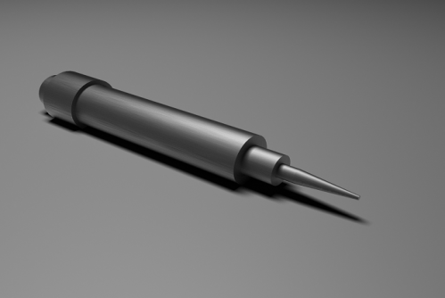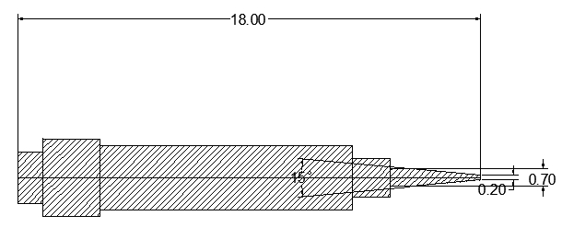

**技术参数**

|  |  |  |  |  |  |  |  |  |
| --- | --- | --- | --- | --- | --- | --- | --- | --- |
| NO | Part No | ￠A | | ￠B | | ￠C | | 芯片范围 |
| inch | mm | inch | mm | inch | mm | inch |
| 1 | FY-18-2.5-15-0.25-0.10 | 0.010 | 0.254 | 0.004 | 0.102 | 0.004 | 0.102 | 7～8 |
| 2 | FY-18-2.5-15-0.30-0.10 | 0.012 | 0.305 | 0.004 | 0.102 | 0.004 | 0.102 | 7～9 |
| 3 | FY-18-2.5-15-0.30-0.15 | 0.012 | 0.305 | 0.006 | 0.152 | 0.004 | 0.102 | 7～10 |
| 4 | FY-18-2.5-15-0.35-0.10 | 0.014 | 0.356 | 0.004 | 0.102 | 0.004 | 0.102 | 7～11 |
| 5 | FY-18-2.5-15-0.35-0.15 | 0.014 | 0.356 | 0.006 | 0.152 | 0.004 | 0.102 | 7～12 |
| 6 | FY-18-2.5-15-0.40-0.15 | 0.020 | 0.500 | 0.006 | 0.152 | 0.004 | 0.102 | 7～13 |
| 7 | FY-18-2.5-15-0.40-0.20 | 0.020 | 0.500 | 0.008 | 0.204 | 0.004 | 0.102 | 7～14 |
| 8 | FY-18-2.5-15-0.50-0.15 | 0.025 | 0.100 | 0.006 | 0.152 | 0.004 | 0.102 | 7～15 |
| 9 | FY-18-2.5-15-0.50-0.20 | 0.025 | 0.100 | 0.008 | 0.204 | 0.004 | 0.102 | 9～12 |
| 10 | FY-18-2.5-15X.XX-X.xx | x.xxx | x.xxx | x.xxx | x.xxx | 0.004 | 0.102 | xx～xx |

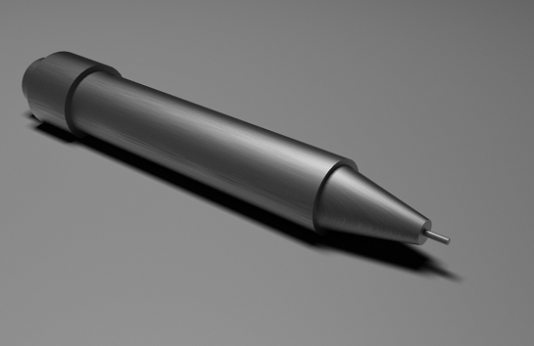

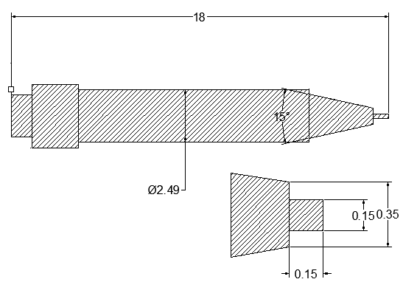

**技术参数**

|  |  |  |  |  |  |  |  |  |
| --- | --- | --- | --- | --- | --- | --- | --- | --- |
| NO | Part No | ￠A | | ￠B | | ￠C | | 芯片范围 |
| inch | mm | inch | mm | inch | mm | inch |
| 1 | FY-18-2.5-15-0.25-0.10 | 0.010 | 0.254 | 0.004 | 0.102 | 0.004 | 0.102 | 7～8 |
| 2 | FY-18-2.5-15-0.30-0.10 | 0.012 | 0.305 | 0.004 | 0.102 | 0.004 | 0.102 | 7～9 |
| 3 | FY-18-2.5-15-0.30-0.15 | 0.012 | 0.305 | 0.006 | 0.152 | 0.004 | 0.102 | 7～10 |
| 4 | FY-18-2.5-15-0.35-0.10 | 0.014 | 0.356 | 0.004 | 0.102 | 0.004 | 0.102 | 7～11 |
| 5 | FY-18-2.5-15-0.35-0.15 | 0.014 | 0.356 | 0.006 | 0.152 | 0.004 | 0.102 | 7～12 |
| 6 | FY-18-2.5-15-0.40-0.15 | 0.020 | 0.500 | 0.006 | 0.152 | 0.004 | 0.102 | 7～13 |
| 7 | FY-18-2.5-15-0.40-0.20 | 0.020 | 0.500 | 0.008 | 0.204 | 0.004 | 0.102 | 7～14 |
| 8 | FY-18-2.5-15-0.50-0.15 | 0.025 | 0.100 | 0.006 | 0.152 | 0.004 | 0.102 | 7～15 |
| 9 | FY-18-2.5-15-0.50-0.20 | 0.025 | 0.100 | 0.008 | 0.204 | 0.004 | 0.102 | 9～12 |
| 10 | FY-18-2.5-15-X.XX-X.xx | x.xxx | x.xxx | x.xxx | x.xxx | 0.004 | 0.102 | xx～xx |

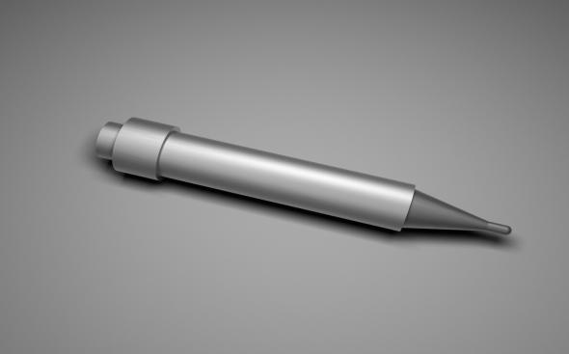

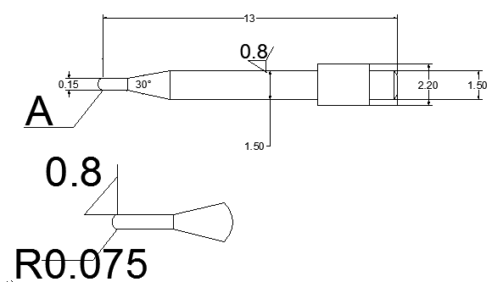

**技术参数**

|  |  |  |  |  |  |  |  |  |
| --- | --- | --- | --- | --- | --- | --- | --- | --- |
| NO | Part No | ￠A | | ￠B | | ￠C | | 芯片范围 |
| inch | mm | inch | mm | inch | mm | inch |
| 1 | FY-13-1.5-30-0.25-0.10 | 0.010 | 0.254 | 0.004 | 0.102 | 0.004 | 0.102 | 7～8 |
| 2 | FY-13-1.5-30-0.30-0.10 | 0.012 | 0.305 | 0.004 | 0.102 | 0.004 | 0.102 | 7～9 |
| 3 | FY-13-1.5-30-0.30-0.15 | 0.012 | 0.305 | 0.006 | 0.152 | 0.004 | 0.102 | 7～10 |
| 4 | FY-13-1.5-30-0.35-0.10 | 0.014 | 0.356 | 0.004 | 0.102 | 0.004 | 0.102 | 7～11 |
| 5 | FY-13-1.5-30-0.35-0.15 | 0.014 | 0.356 | 0.006 | 0.152 | 0.004 | 0.102 | 7～12 |
| 6 | FY-13-1.5-30-0.40-0.15 | 0.020 | 0.500 | 0.006 | 0.152 | 0.004 | 0.102 | 7～13 |
| 7 | FY-13-1.5-30-0.40-0.20 | 0.020 | 0.500 | 0.008 | 0.204 | 0.004 | 0.102 | 7～14 |
| 8 | FY-13-1.5-30-0.50-0.15 | 0.025 | 0.100 | 0.006 | 0.152 | 0.004 | 0.102 | 7～15 |
| 9 | FY-13-1.5-30-0.50-0.20 | 0.025 | 0.100 | 0.008 | 0.204 | 0.004 | 0.102 | 9～12 |
| 10 | FY-13-1.5-30-X.XX-X.xx | x.xxx | x.xxx | x.xxx | x.xxx | 0.004 | 0.102 | xx～xx |

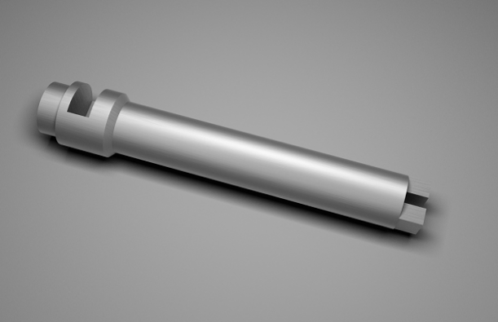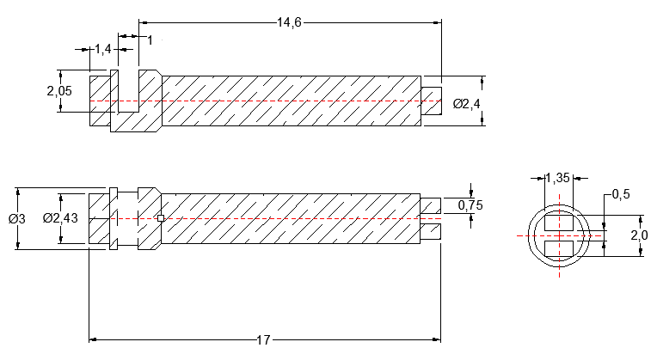

|  |  |  |  |  |  |  |
| --- | --- | --- | --- | --- | --- | --- |
| **14.6-2D** |  |  |  |  |  |  |
| **NO** | **Part No** | **L** | **X** | **Y** | **C** | **DФ** |
| **MM** | **MM** | **MM** | **MM** | **MM** |
| **1** | **FY-14.60-2D-XX** | **14.60** | **Specity** | **Specity** | **Specity** | **Specity** |

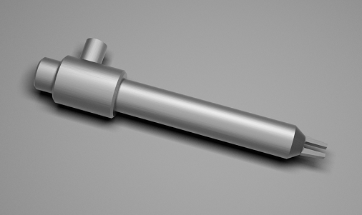

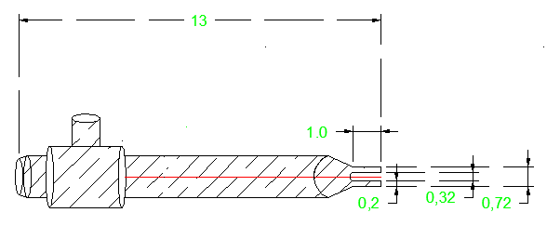

|  |  |  |  |  |  |  |
| --- | --- | --- | --- | --- | --- | --- |
|  |  |  |  |  |  |  |
| **NO** | **Part No** | **L** | **X** | **Y** | **C** | **DФ** |
| **MM** | **MM** | **MM** | **MM** | **MM** |
| **1** | **FY-1300-2D-XX** | **13.00** | **Specity** | **Specity** | **Specity** | **Specity** |

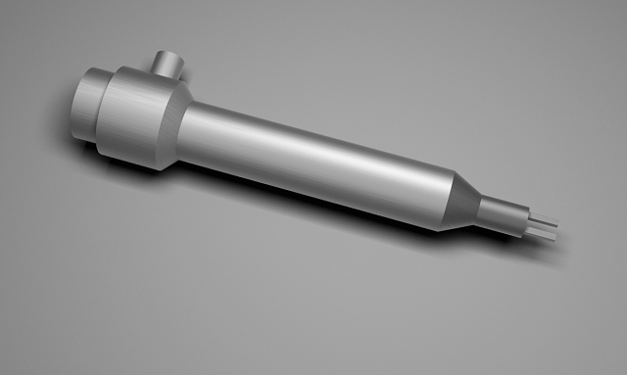

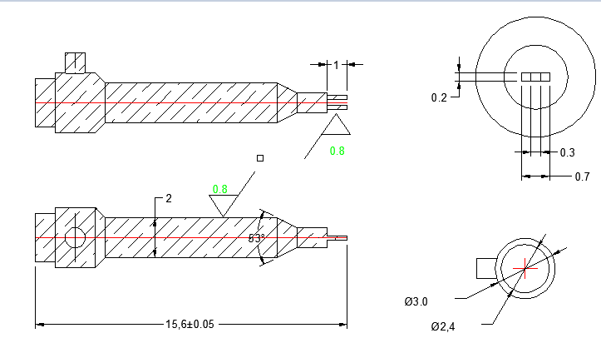

|  |  |  |  |  |  |  |
| --- | --- | --- | --- | --- | --- | --- |
| **15.6-2D** |  |  |  |  |  |  |
| **NO** | **Part No** | **L** | **X** | **Y** | **C** | **DФ** |
| **MM** | **MM** | **MM** | **MM** | **MM** |
| **1** | **FY-15.60-2D-XX** | **15.60** | **Specity** | **Specity** | **Specity** | **Specity** |

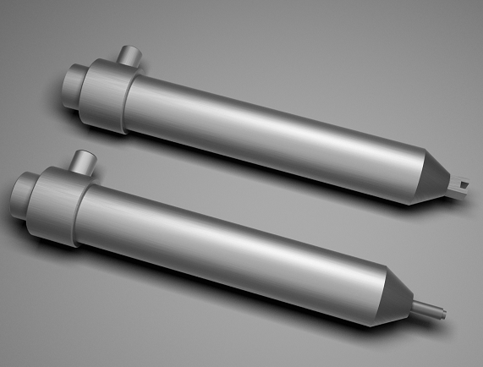

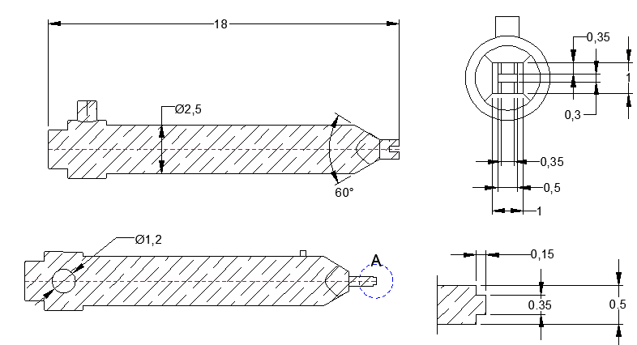

|  |  |  |  |  |  |  |
| --- | --- | --- | --- | --- | --- | --- |
| **18-2D** |  |  |  |  |  |  |
| **NO** | **Part No** | **L** | **X** | **Y** | **C** | **DФ** |
| **MM** | **MM** | **MM** | **MM** | **MM** |
| **1** | **FY-1800-2D-XX** | **18.00** | **Specity** | **Specity** | **Specity** | **Specity** |

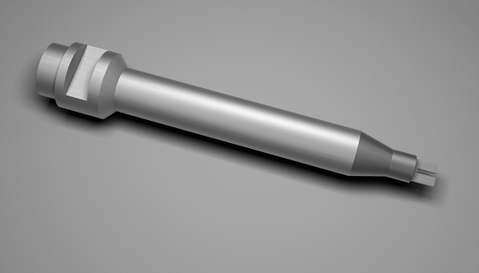

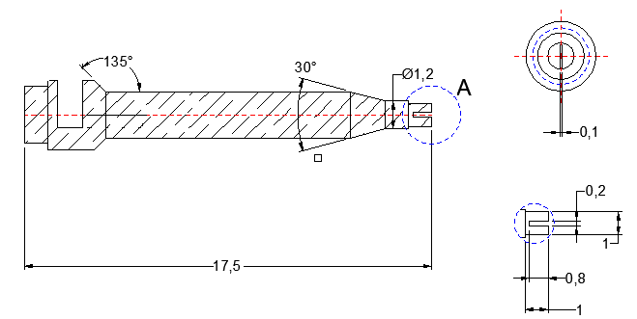

|  |  |  |  |  |  |  |
| --- | --- | --- | --- | --- | --- | --- |
| **17.5-2D** |  |  |  |  |  |  |
| **NO** | **Part No** | **L** | **X** | **Y** | **C** | **DФ** |
| **MM** | **MM** | **MM** | **MM** | **MM** |
| **1** | **FY-17.502D-XX** | **17.50** | **Specity** | **Specity** | **Specity** | **Specity** |

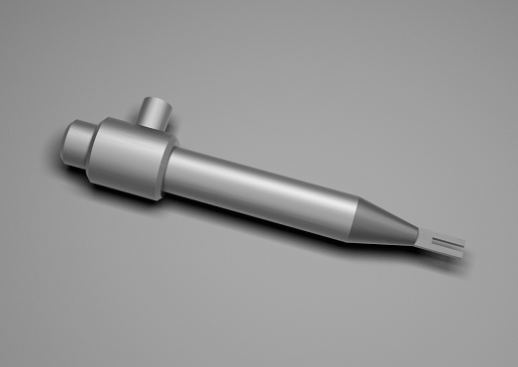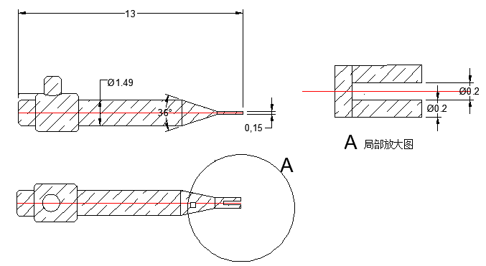

|  |  |  |  |  |  |  |
| --- | --- | --- | --- | --- | --- | --- |
| **13-2D** |  |  |  |  |  |  |
| **NO** | **Part No** | **L** | **X** | **Y** | **C** | **DФ** |
| **MM** | **MM** | **MM** | **MM** | **MM** |
| **1** | **FY-1300-2D-XX** | **13.00** | **Specity** | **Specity** | **Specity** | **Specity** |

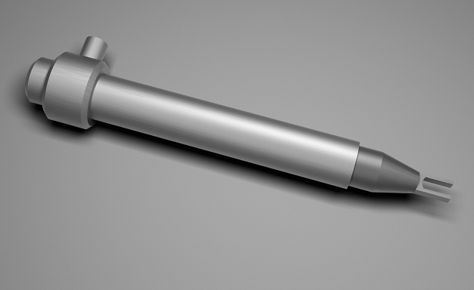

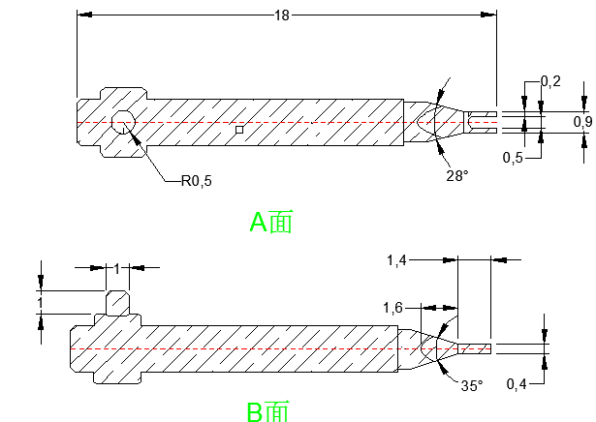

|  |  |  |  |  |  |  |
| --- | --- | --- | --- | --- | --- | --- |
| **18-2D** |  |  |  |  |  |  |
| **NO** | **Part No** | **L** | **X** | **Y** | **C** | **DФ** |
| **MM** | **MM** | **MM** | **MM** | **MM** |
| **1** | **FY-1800-2D-XX** | **18.00** | **Specity** | **Specity** | **Specity** | **Specity** |

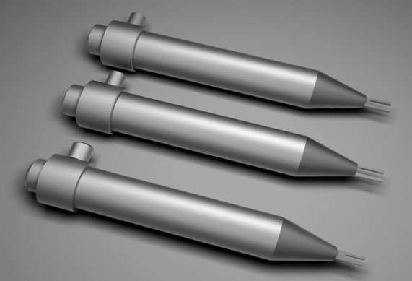

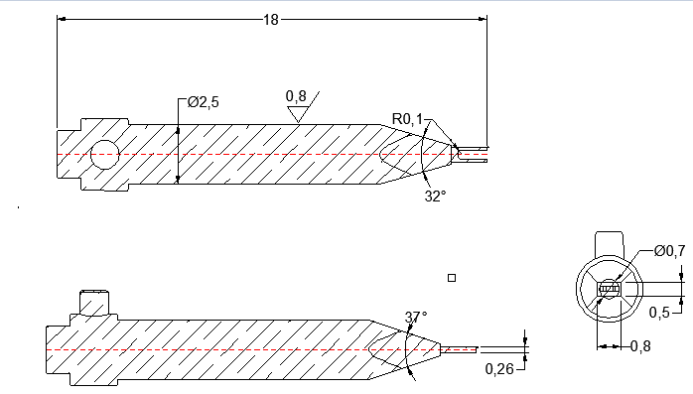

|  |  |  |  |  |  |  |
| --- | --- | --- | --- | --- | --- | --- |
| **18-2D** |  |  |  |  |  |  |
| **NO** | **Part No** | **L** | **X** | **Y** | **C** | **DФ** |
| **MM** | **MM** | **MM** | **MM** | **MM** |
| **1** | **FY-1800-2D-XX** | **18.00** | **Specity** | **Specity** | **Specity** | **Specity** |

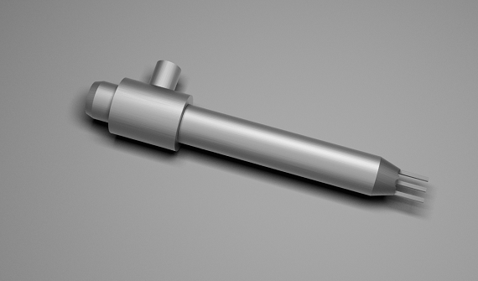

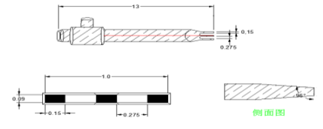

|  |  |  |  |  |  |  |
| --- | --- | --- | --- | --- | --- | --- |
| **13-3D** |  |  |  |  |  |  |
| **NO** | **Part No** | **L** | **X** | **Y** | **C** | **DФ** |
| **MM** | **MM** | **MM** | **MM** | **MM** |
| **1** | **FY-1300-3D-XX** | **13.00** | **Specity** | **Specity** | **Specity** | **Specity** |

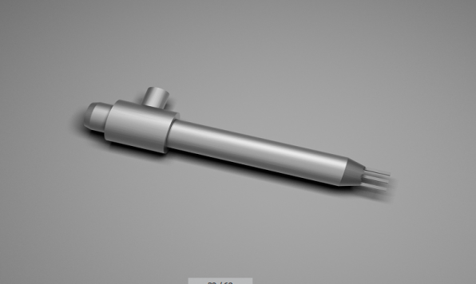

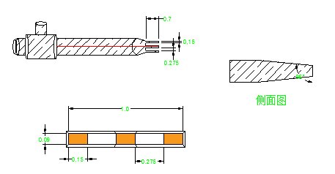

|  |  |  |  |  |  |  |
| --- | --- | --- | --- | --- | --- | --- |
| **13-3D** |  |  |  |  |  |  |
| **NO** | **Part No** | **L** | **X** | **Y** | **C** | **DФ** |
| **MM** | **MM** | **MM** | **MM** | **MM** |
| **1** | **FY-1300-3D-XX** | **13.00** | **Specity** | **Specity** | **Specity** | **Specity** |

名称：点胶嘴

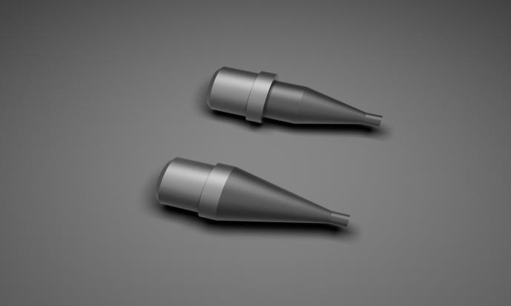

材质：316不锈钢

产品概述:

独家镀层技术使用过程中不粘胶避免堵塞和拉丝，高流量、高精度。专利薄壁技术使较小口径产品拥有较大流量，减少输胶压力，提高输送性能并延长设备使用寿命。可根据客户不同需求订制。

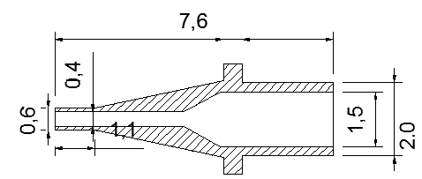

**技术参数（灵感）**

|  |  |  |
| --- | --- | --- |
| No | Part NO | mm |
| 1 | FY-SS-L-0.3 | 0.30 |
| 2 | FY-SS-L-0.4 | 0.40 |
| 3 | FY-SS-L-0.5 | 0.50 |
| 4 | FY-SS-L-0.6 | 0.60 |

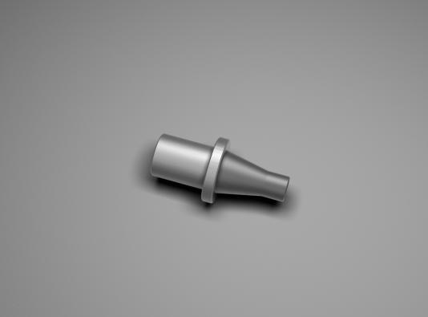

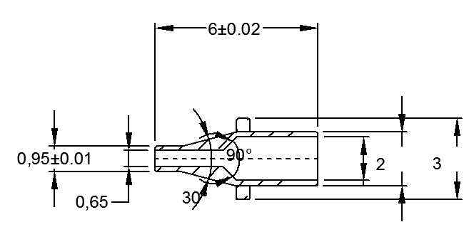

**技术参数（灵感）**

|  |  |  |
| --- | --- | --- |
| No | Part NO | mm |
| 1 | FY-SS-L-0.3 | 0.30 |
| 2 | FY-SS-L-0.4 | 0.40 |
| 3 | FY-SS-L-0.5 | 0.50 |
| 4 | FY-SS-L-0.6 | 0.60 |

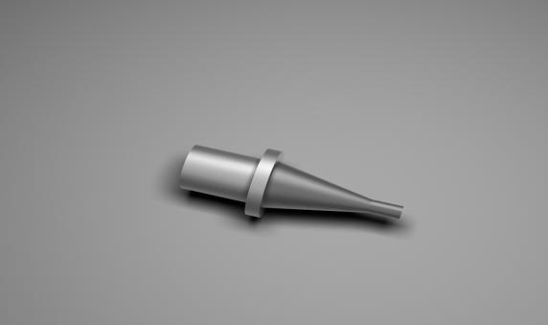



**技术参数(灵感）**

|  |  |  |
| --- | --- | --- |
| No | Part NO | mm |
| 1 | FY-SS-L-0.3 | 0.30 |
| 2 | FY-SS-L-0.4 | 0.40 |
| 3 | FY-SS-L-0.5 | 0.50 |
| 4 | FY-SS-L-0.6 | 0.60 |

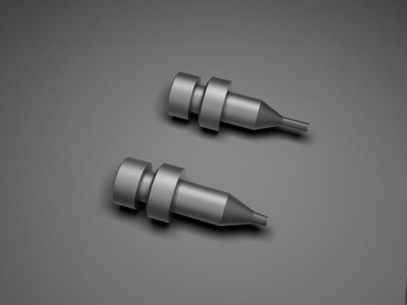

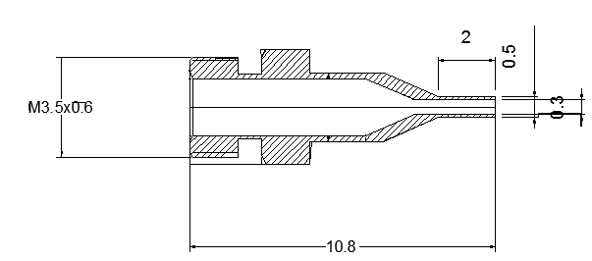

**技术参数（五藏分体点胶嘴）**

|  |  |  |
| --- | --- | --- |
| No | Part NO | mm |
| 1 | FY-SS-L-0.3 | 0.30 |
| 2 | FY-SS-L-0.4 | 0.40 |
| 3 | FY-SS-L-0.5 | 0.50 |
| 4 | FY-SS-L-0.6 | 0.60 |

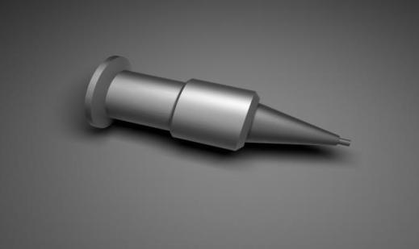

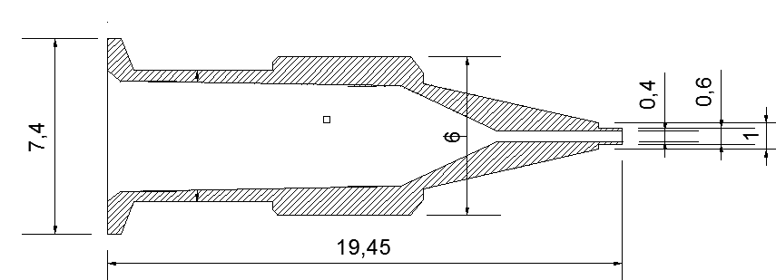

**技术参数（五藏整体点胶嘴）**

|  |  |  |
| --- | --- | --- |
| No | Part NO | mm |
| 1 | FY-SS-L-0.3 | 0.30 |
| 2 | FY-SS-L-0.4 | 0.40 |
| 3 | FY-SS-L-0.5 | 0.50 |
| 4 | FY-SS-L-0.6 | 0.60 |

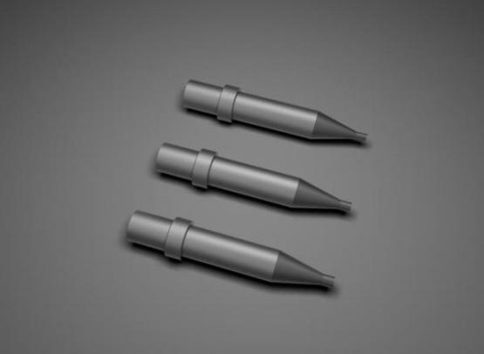

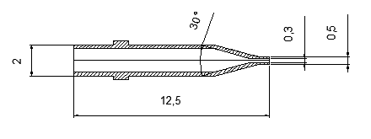

**技术参数（喷嘴）**

|  |  |  |
| --- | --- | --- |
| No | Part NO | mm |
| 1 | FY-SS-L-0.3 | 0.30 |
| 2 | FY-SS-L-0.4 | 0.40 |
| 3 | FY-SS-L-0.5 | 0.50 |
| 4 | FY-SS-L-0.6 | 0.60 |

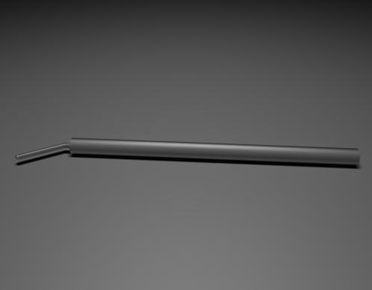名称：打火杆

材质：铂金

产品概述：

打火杆由铂金材料加工而成，具有高导电、耐高温等特点。

打火杆用于LED焊线机上起生产高压放电，将金线、铜线、

合金线等介质熔断烧球作用，这个过程也叫EFO作用。

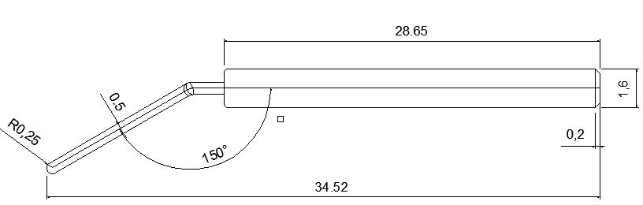技术参数

|  |  |  |  |
| --- | --- | --- | --- |
| NO | Part No | MODEL |  |
| 1 | FY-014-01 | ASM | Eg60 |

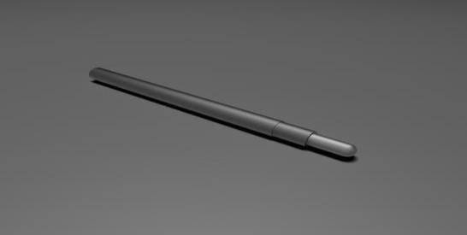

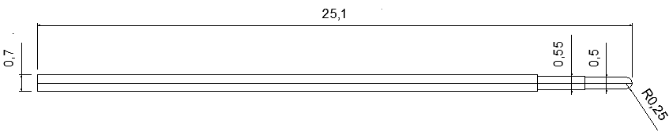

技术参数

|  |  |  |  |
| --- | --- | --- | --- |
| NO | Part No | MODEL |  |
| 1 | FY-014-02 | KS |  |

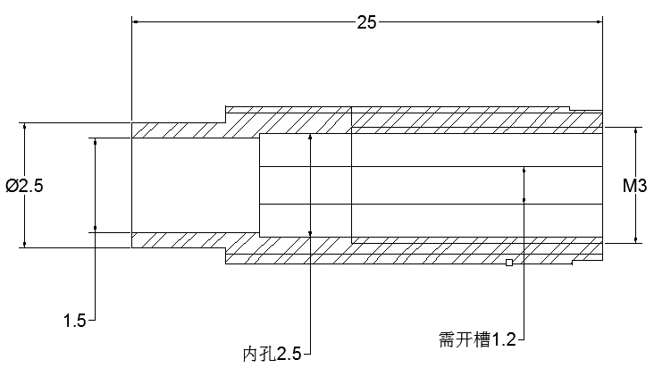

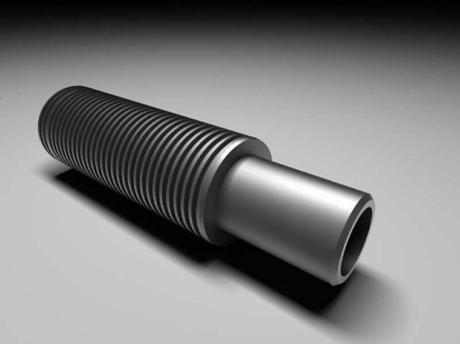**技术参数**

|  |  |  |  |
| --- | --- | --- | --- |
| NO | Part No | L | AФ |
| MM |
| 1 | FY-01-13-1.0 | 13.00 | 1.0 |
| 2 | FY-01-13-1.2 | 13.00 | 1.2 |
| 3 | FY-01-13-1.5 | 13.00 | 1.5 |

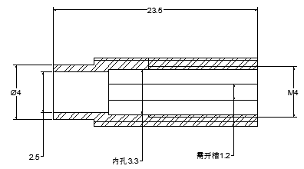

**技术参数**

|  |  |  |  |
| --- | --- | --- | --- |
| 324611366218796712NO | Part No | L | AФ |
| MM |
| 1 | FY-01-18-1.5 | 18.00 | 1.5 |
| 2 | FY-01-18-2.5 | 18.00 | 2.5 |
| 3 | FY-01-18-XX | 18.00 | XX |

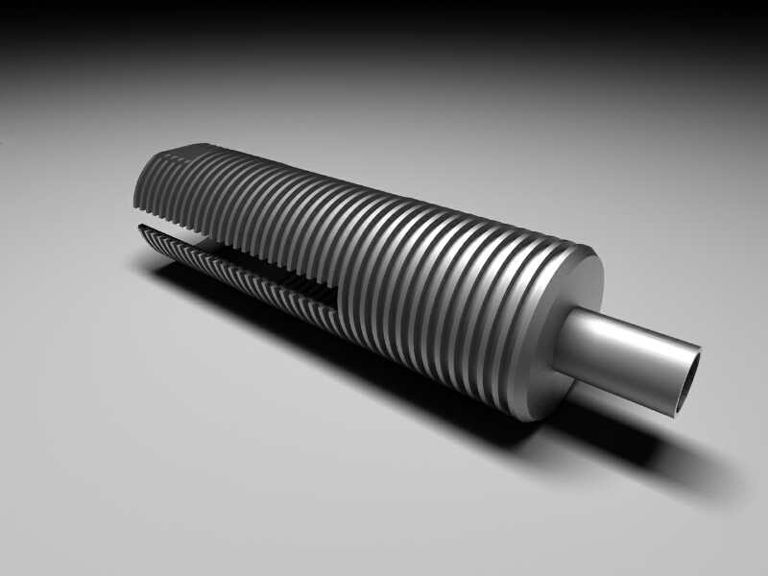

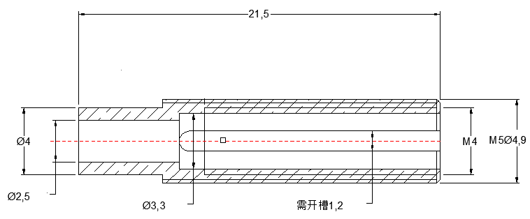

**技术参数**

|  |  |  |  |
| --- | --- | --- | --- |
| NO | Part No | L | AФ |
| MM |
| 1 | FY-01-18-1.5 | 18.00 | 1.5 |
| 2 | FY-01-18-2.5 | 18.00 | 2.5 |
| 3 | FY-01-18-XX | 18.00 | XX |



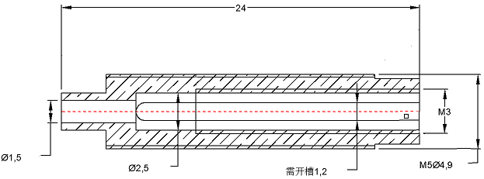

**技术参数**

|  |  |  |  |
| --- | --- | --- | --- |
| NO | Part No | L | AФ |
| MM |
| 1 | FY-01-18-1.5 | 18.00 | 1.5 |
| 2 | FY-01-18-2.5 | 18.00 | 2.5 |
| 3 | FY-01-18-XX | 18.00 | XX |

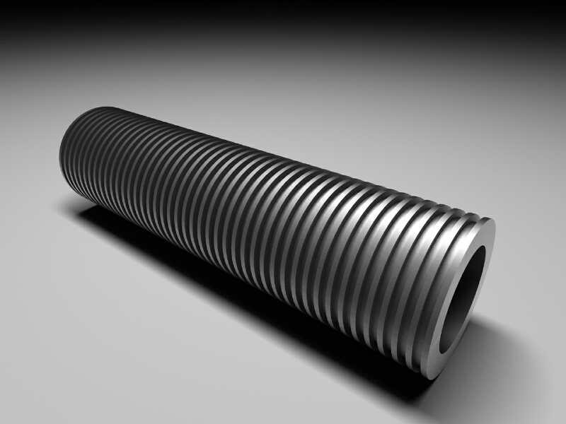

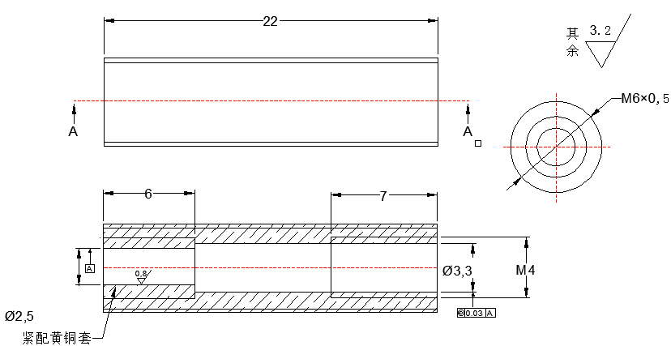

**技术参数**

|  |  |  |  |
| --- | --- | --- | --- |
| NO | Part No | L | AФ |
| MM |
| 1 | FY-01-18-1.5 | 18.00 | 1.5 |
| 2 | FY-01-18-2.5 | 18.00 | 2.5 |
| 3 | FY-01-18-XX | 18.00 | XX |